CSS ISLAMIC STUDIES · T5QA
بِسۡمِ ٱللَّهِ ٱلرَّحۡمَٰنِ ٱلرَّحِيمِ
Topic V — Islamic Civilization and Culture
The Question Answers · Every past-paper question of Topic 5, 2016–2025, answered as a model
Nine model answers — culture and characteristics, self-purification three times in three shapes, Sufism, moral values, the classist lifestyle and tolerance in Muslim history. Each begins with an answer map that states exactly what the question asks, builds its headings from the question's own words, and proves every heading from the Quran, the Sunnah and history.
Edition of September 2026 · covers the papers of 2015–2026 · written for CSS 2027 and after
Contents
HOW TO BUILD THE CONTENTS
The Contents below is left empty on purpose. In Microsoft Word, right-click anywhere on the grey line below and choose Update Field → Update entire table → OK. The full table of contents with page numbers will appear.
On a Mac: right-click (or Control-click) the line → Update Field. If you edit the notes later, repeat this step to refresh the page numbers. You can also press Ctrl + A then F9 (Windows) to update every field in the document at once.

How to Use These Answers 6
What is in this document 6
How every answer is built 6
Answer 1 · Culture, Civilization and the Characteristics of Islamic Culture (CSS 2016) 7
Decoding the question 7
The model answer 7
(1) Introduction 7
(2) The meaning of culture 7
(3) The meaning of civilization 8
(4) Culture and civilization — the difference 8
(5) The characteristics of Islamic culture 8
(6) Conclusion 12
Why this answer scores 13
Answer 2 · The Basic Characteristics of Islamic Civilization, in Detail (CSS 2018) 14
Decoding the question 14
The model answer 14
(1) Introduction 14
(2) Tawhid — the root 15
(3) Tazkiyah — the trunk 16
(4) The dignity of man 16
(5) Equality 16
(6) Social justice 17
(7) Moral values 17
(8) Tolerance 17
(9) Rule of law 18
(10) The fruits — the proof in history 18
(11) Conclusion 18
Why this answer scores 18
Answer 3 · The Moral Value System of Islam as a Feature of Islamic Civilization (CSS 2019) 19
Decoding the question 19
The model answer 20
(1) Introduction 20
(2) The sources of Islamic morality 20
(3) The features of the moral system 20
(4) The Quranic moral code — Surah Al-Isra (17:23–37) 21
(5) The core moral values 21
(6) Islamic morality and secular ethics 22
(7) Morality as a significant feature of Islamic civilization 23
(8) Conclusion 23
Why this answer scores 24
Answer 4 · Self-Purification in the Quran and Sunnah and Its Impact on Society (CSS 2017) 25
Decoding the question 25
The model answer 26
(1) Introduction 26
(2) The concept of self-purification 26
(3) Self-purification in the Quran 26
(4) Self-purification in the Sunnah 27
(5) The means of self-purification 27
(6) The impact of self-purification on society 28
(7) The proof in history 29
(8) Conclusion 29
Why this answer scores 29
Answer 5 · Self-Purification and Ihsan: Their Individual and Collective Impacts (CSS 2018) 30
Decoding the question 30
The model answer 30
(1) Introduction 30
(2) What is self-purification? 30
(3) What is Ihsan? 31
(4) The relation between the two 32
(5) The individual impacts 32
(6) The collective impacts 32
(7) Conclusion 33
Why this answer scores 33
Answer 6 · Self-Purification: An Essential Element for the Evolution of Society (CSS 2024) 34
Decoding the question 34
The model answer 34
(1) Introduction 34
(2) The Quranic law of social change 35
(3) The mechanism — from the heart to the civilization 35
(4) The historical proof 36
(5) Decline without self-purification 36
(6) The counter-view and the Islamic synthesis 36
(7) A roadmap for Pakistan 37
(8) Conclusion 37
Why this answer scores 38
Answer 7 · Sufism and the Spread of Islam; Can It Reform Today's Deviations? (CSS 2021) 39
Decoding the question 39
The model answer 39
(1) Introduction 39
(2) The meaning and basis of Sufism 40
(3) The importance of Sufism in the spread of Islam 40
(4) The current deviations 41
(5) Is reform possible through Sufism? — Yes, on conditions 42
(6) Conclusion 42
Why this answer scores 43
Answer 8 · The Classist Lifestyle in the Light of Islam and Its Effects on Society (CSS 2025) 44
Decoding the question 44
The model answer 44
(1) Introduction 44
(2) Islam's principle — the equality of all 45
(3) Differences in wealth — a test, not a rank 45
(4) The status of the classist lifestyle — condemned on six counts 46
(5) The Islamic alternative 48
(6) The effects of the classist lifestyle on society 48
(7) The remedy 48
(8) Conclusion 49
Why this answer scores 49
Answer 9 · Religious Tolerance in Post-Prophetic Muslim History (CSS 2025) 50
Decoding the question 50
The model answer 50
(1) Introduction 50
(2) The foundation 51
(3) The Rightly-Guided Caliphs (632–661) 52
(4) Tolerance as state policy 52
(5) The Umayyads and Sindh (712) 52
(6) The Abbasids — Baghdad 52
(7) Muslim Spain — Cordoba (929–1031) 53
(8) Salahuddin and Jerusalem (1187) 53
(9) The Ottomans 53
(10) The subcontinent and Pakistan 53
(11) Honest limits 53
(12) Conclusion 54
Why this answer scores 54

How to Use These Answers

What is in this document
# | Paper | Question (short) | Answer
1 | 2016 Q2 | Meaning of culture and civilization; characteristics of Islamic culture | Answer 1
2 | 2018 Q7 | The basic characteristics of Islamic civilization, in detail | Answer 2
3 | 2019 Q5 | The moral value system of Islam as a feature of Islamic civilization | Answer 3
4 | 2017 Q6 | Self-purification in the Quran and Sunnah, and its impact on society | Answer 4
5 | 2018 Q3 | Self-purification and Ihsan; their individual and collective impacts | Answer 5
6 | 2024 Q2 | Self-purification as an essential element for the evolution of society | Answer 6
7 | 2021 Q7 | Sufism and the spread of Islam; can it reform today's deviations? | Answer 7
8 | 2025 Q4 | The classist lifestyle in the light of Islam, and its effects | Answer 8
9 | 2025 Q7 | Religious tolerance in post-Prophetic Muslim history | Answer 9

The three self-purification questions are answered in three different shapes — society by sectors (2017), two concepts with two kinds of impact (2018), and a thesis on social evolution (2024) — as their wordings demand.

How every answer is built
1. The question, exactly as set.
2. The answer map — the centre states exactly what the question asks; every box is a heading, and every point is a complete idea.
3. Decoding the question.
4. The model answer — headings from the question's words; evidence Quran → Hadith → history → scholars; figures; Pakistan; a conclusion with a verse or hadith.
5. Why this answer scores.
TRAP · USE THE ANSWERS AS MODELS, NOT SCRIPTS
Learn the structure and the evidence; build your headings from the words of the question you are given. Choose what you can reproduce well in 33 minutes.

Answer 1 · Culture, Civilization and the Characteristics of Islamic Culture (CSS 2016)
THE QUESTION · CSS 2016 · Q2 · 20 marks
What is meant by culture and civilization? Describe the characteristics of Islamic culture.

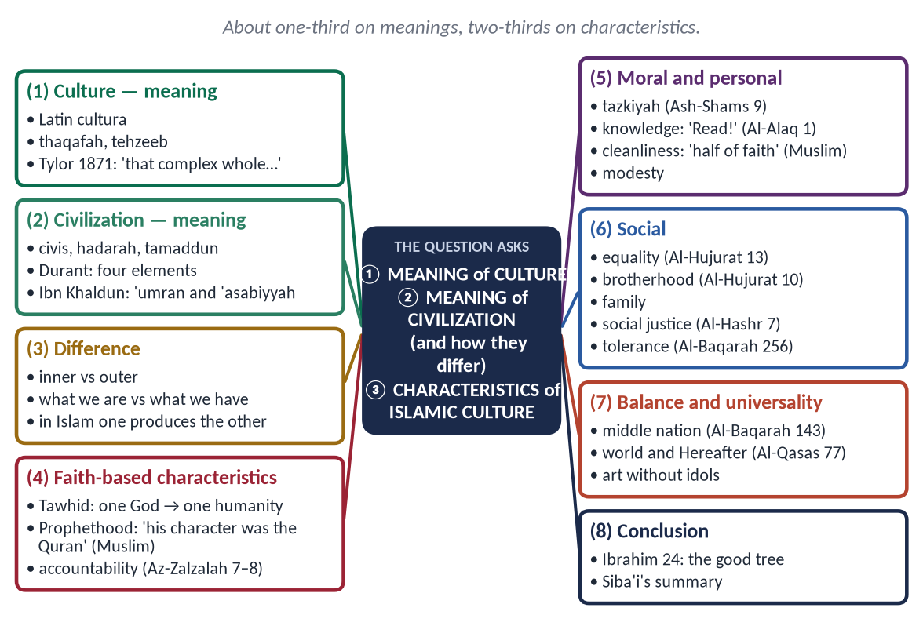
Figure 1 · The answer map: every branch is one numbered heading of the model answer below.

Decoding the question
- Two definitions — culture and civilization — with their difference.
- 'Characteristics of Islamic culture' — the main body: each characteristic a heading with evidence.

The model answer

(1) Introduction
Every people has a way of living and a set of achievements. The first is its culture, the second its civilization. Islam gave the world both: a culture rooted in faith and morality, and a civilization that stretched from Spain to Indonesia.

(2) The meaning of culture
- Words: Latin cultura — cultivation of the soil, then of the mind; Arabic thaqafah (ثَقَافَة) — refining; Urdu tehzeeb (تہذیب) — pruning a tree.
✦ SCHOLARLY VIEW
E. B. Tylor · Primitive Culture (1871)
“Culture … is that complex whole which includes knowledge, belief, art, morals, law, custom, and any other capabilities and habits acquired by man as a member of society.”

- Simply: culture is the way of life of a people — beliefs, values, language, manners, customs and arts.

(3) The meaning of civilization
- Words: Latin civis/civitas (citizen, city); Arabic hadarah (حَضَارَة — settled life) and tamaddun (تَمَدُّن — from madinah).
✦ SCHOLARLY VIEW
Will Durant · The Story of Civilization (1935)
“Civilization is social order promoting cultural creation. Four elements constitute it: economic provision, political organization, moral traditions, and the pursuit of knowledge and the arts.”

✦ SCHOLARLY VIEW
Ibn Khaldun · Al-Muqaddimah (1377)
Ibn Khaldun called civilization 'umran, traced it from desert life to city life, held together by 'asabiyyah, and warned that luxury and moral decay destroy it.
➜ The first sociologist of civilization.

(4) Culture and civilization — the difference
Point | Culture | Civilization
Nature | Inner — beliefs, values, manners | Outer — institutions, cities, sciences
Question | What we are | What we have
Borrowing | Hard — tied to faith | Easy — technology, systems
Example | Modesty, hospitality | Universities, courts, hospitals

In Islam they are one: the inner culture produces the outer civilization.

(5) The characteristics of Islamic culture

(i) Tawhid — the foundation
✦ QURAN
﴿قُلۡ هُوَ ٱللَّهُ أَحَدٌ﴾
“Say, "He is Allah, [who is] One.” (Al-Ikhlas, Quran)
➜ 'Say: He is Allah, the One.'

One God means one humanity, freedom from all false lords, and unity of religion and life. Iqbal: Tawhid as a working idea is equality, solidarity and freedom.

(ii) Prophethood — the living model
✦ HADITH
كَانَ خُلُقُهُ الْقُرْآنَ
“His character was the Quran.” (Muslim)
➜ The Prophet ﷺ is the pattern of Islamic culture (Al-Ahzab 21).

(iii) Accountability in the Hereafter
✦ QURAN
﴿فَمَن يَعۡمَلۡ مِثۡقَالَ ذَرَّةٍ خَيۡرٗا يَرَهُۥ ۝ وَمَن يَعۡمَلۡ مِثۡقَالَ ذَرَّةٖ شَرّٗا يَرَهُۥ﴾
“So whoever does an atom's weight of good will see it. And whoever does an atom's weight of evil will see it.” (Az-Zalzalah, Quran)
➜ Whoever does an atom's weight of good will see it, and whoever does an atom's weight of evil will see it — the inner police of the culture.

(iv) Self-purification
✦ QURAN
﴿قَدۡ أَفۡلَحَ مَن زَكَّىٰهَا ۝ وَقَدۡ خَابَ مَن دَسَّىٰهَا﴾
“He has succeeded who purifies it. And he has failed who instills it [with corruption].” (Ash-Shams, Quran)
➜ 'He has succeeded who purifies it, and he has failed who corrupts it.'

(v) Knowledge
✦ QURAN
﴿ٱقۡرَأۡ بِٱسۡمِ رَبِّكَ ٱلَّذِي خَلَقَ﴾
“Recite in the name of your Lord who created.” (Al-Alaq, Quran)
➜ 'Read in the name of your Lord who created' — a culture that began with a command to read; it produced Al-Khwarizmi, Ibn Sina and Al-Biruni.

(vi) Cleanliness and modesty
✦ HADITH
الطُّهُورُ شَطْرُ الْإِيمَانِ
“Purity is half of faith.” (Muslim)
➜ Wudu, bathing, clean dress and clean streets; modesty 'a branch of faith' (Al-Bukhari and Muslim).

(vii) Equality and brotherhood
✦ QURAN
﴿يَـٰٓأَيُّهَا ٱلنَّاسُ إِنَّا خَلَقۡنَٰكُم مِّن ذَكَرٖ وَأُنثَىٰ وَجَعَلۡنَٰكُمۡ شُعُوبٗا وَقَبَآئِلَ لِتَعَارَفُوٓاْۚ إِنَّ أَكۡرَمَكُمۡ عِندَ ٱللَّهِ أَتۡقَىٰكُمۡۚ إِنَّ ٱللَّهَ عَلِيمٌ خَبِيرٞ﴾
“O mankind, indeed We have created you from male and female and made you peoples and tribes that you may know one another. Indeed, the most noble of you in the sight of Allah is the most righteous of you. Indeed, Allah is Knowing and Acquainted.” (Al-Hujurat, Quran)
➜ The most honoured is the most righteous — not the richest or the noblest-born.

✦ QURAN
﴿إِنَّمَا ٱلۡمُؤۡمِنُونَ إِخۡوَةٞ فَأَصۡلِحُواْ بَيۡنَ أَخَوَيۡكُمۡۚ وَٱتَّقُواْ ٱللَّهَ لَعَلَّكُمۡ تُرۡحَمُونَ﴾
“The believers are but brothers, so make settlement between your brothers. And fear Allah that you may receive mercy.” (Al-Hujurat, Quran)
➜ 'The believers are but brothers.'

(viii) The family
Marriage as Sunnah, respect for parents (Al-Isra 23), rights of women and children — the family is the cell of Islamic culture.

(ix) Social justice
✦ QURAN
﴿… كَيۡ لَا يَكُونَ دُولَةَۢ بَيۡنَ ٱلۡأَغۡنِيَآءِ مِنكُمۡۚ …﴾
“… so that it does not circulate only among the rich among you.” (Al-Hashr, Quran)
➜ So that wealth does not circulate only among the rich — Zakat, inheritance, no riba.

(x) Tolerance
✦ QURAN
﴿لَآ إِكۡرَاهَ فِي ٱلدِّينِۖ قَد تَّبَيَّنَ ٱلرُّشۡدُ مِنَ ٱلۡغَيِّۚ …﴾
“There is no compulsion in religion; the right course has become clear from the wrong.” (Al-Baqarah, Quran)
➜ No compulsion in religion — the Charter of Madinah, Najran, Umar in Jerusalem.

(xi) Balance and moderation
✦ QURAN
﴿وَكَذَٰلِكَ جَعَلۡنَٰكُمۡ أُمَّةٗ وَسَطٗا لِّتَكُونُواْ شُهَدَآءَ عَلَى ٱلنَّاسِ وَيَكُونَ ٱلرَّسُولُ عَلَيۡكُمۡ شَهِيدٗاۗ …﴾
“And thus We have made you a middle (just) nation, that you may be witnesses over mankind and the Messenger a witness over you.” (Al-Baqarah, Quran)
➜ 'We have made you a middle nation' — neither monasticism nor materialism.

✦ QURAN
﴿وَٱبۡتَغِ فِيمَآ ءَاتَىٰكَ ٱللَّهُ ٱلدَّارَ ٱلۡأٓخِرَةَۖ وَلَا تَنسَ نَصِيبَكَ مِنَ ٱلدُّنۡيَاۖ وَأَحۡسِن كَمَآ أَحۡسَنَ ٱللَّهُ إِلَيۡكَۖ وَلَا تَبۡغِ ٱلۡفَسَادَ فِي ٱلۡأَرۡضِۖ …﴾
“Seek, through what Allah has given you, the home of the Hereafter, and do not forget your share of this world; do good as Allah has done good to you, and do not seek corruption in the land.” (Al-Qasas, Quran)
➜ Seek the Hereafter without forgetting your share of this world.

(xii) Universality and art
Arab, Persian, Turkish, African and Indian peoples shared one culture; art developed calligraphy and geometry instead of images — the Badshahi and Faisal Mosques.
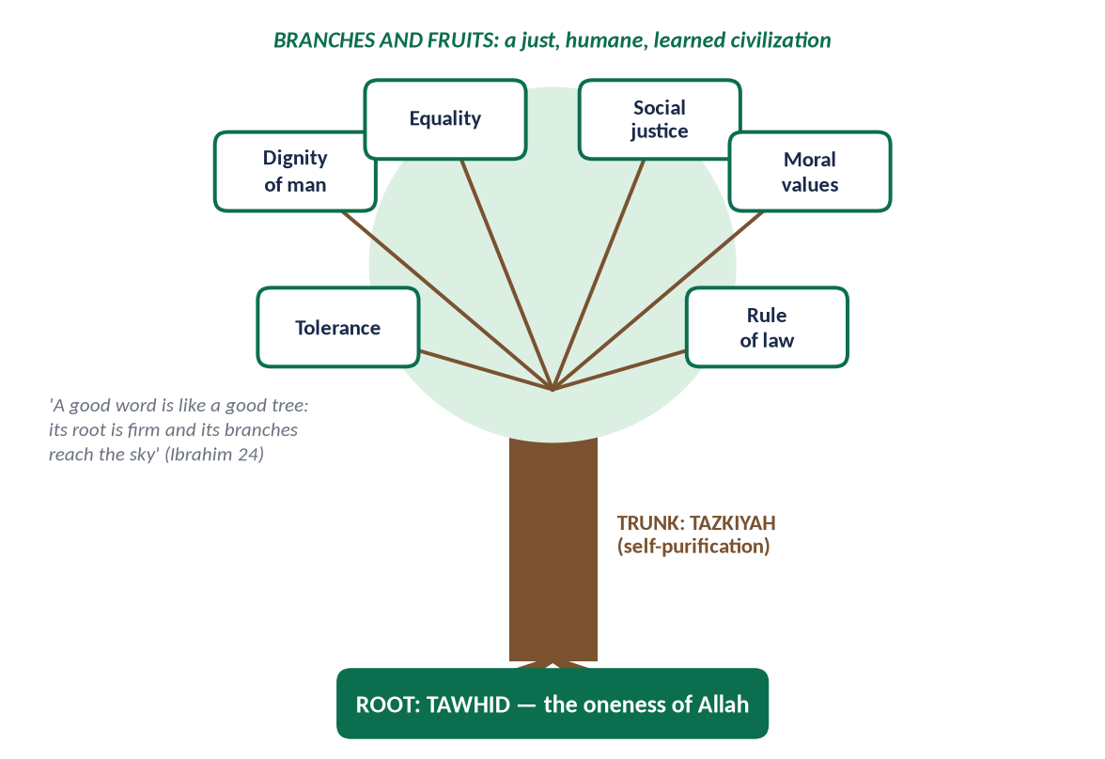
Figure 2 · The characteristics as one tree.
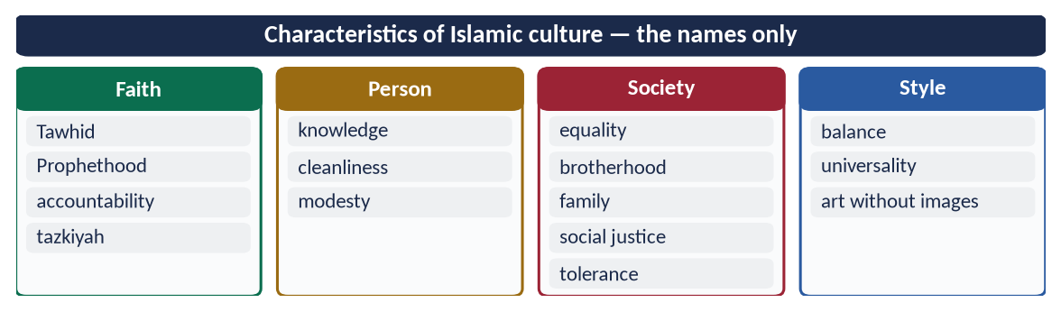
Figure 3 · At a glance — characteristics of Islamic culture — the names only. The detail is in the sections above.

(6) Conclusion
✦ QURAN
﴿… كَلِمَةٗ طَيِّبَةٗ كَشَجَرَةٖ طَيِّبَةٍ أَصۡلُهَا ثَابِتٞ وَفَرۡعُهَا فِي ٱلسَّمَآءِ ۝ تُؤۡتِيٓ أُكُلَهَا كُلَّ حِينِۭ بِإِذۡنِ رَبِّهَاۗ …﴾
“A good word is like a good tree, whose root is firm and whose branches reach the sky; it gives its fruit at every time by the permission of its Lord.” (Ibrahim, Quran)
➜ A good word is like a good tree, whose root is firm and whose branches reach the sky.

✦ SCHOLARLY VIEW
Dr Mustafa al-Siba'i · Min Rawa'i Hadaratina
Islamic civilization was built on pure monotheism, had a universal human aim, made morality the basis of every field, honoured knowledge and practised a tolerance unknown to its age.
➜ The FPSC reading-list summary.

Culture is the root and civilization the fruit. Islamic culture — rooted in Tawhid and purified by tazkiyah — produced a civilization of knowledge, justice and tolerance. Its revival today depends on reviving its culture first.

Why this answer scores
- Both definitions with classic authorities (Tylor, Durant, Ibn Khaldun) and a difference table.
- Twelve characteristics, each with a verse or hadith.
- The tree figure and the Siba'i summary show reading-list knowledge.

Answer 2 · The Basic Characteristics of Islamic Civilization, in Detail (CSS 2018)
THE QUESTION · CSS 2018 · Q7 · 20 marks
Describe, in detail, the basic characteristics of Islamic civilization.

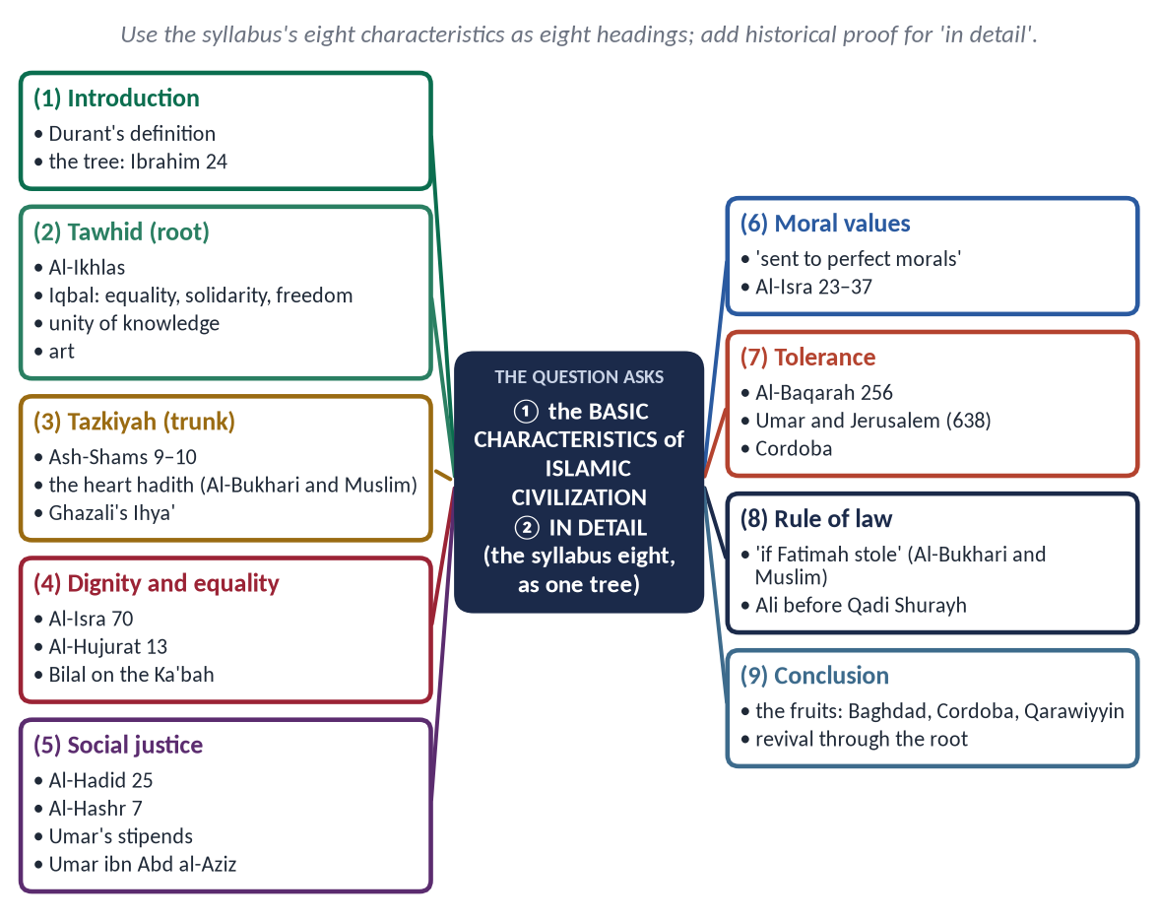
Figure 4 · The answer map: every branch is one numbered heading of the model answer below.

Decoding the question
- 'Basic characteristics' — the defining features; the syllabus names eight — use them.
- 'In detail' — each characteristic with meaning, evidence and a historical example.

The model answer

(1) Introduction
✦ SCHOLARLY VIEW
Will Durant · The Story of Civilization (1935)
“Civilization is social order promoting cultural creation.”

Islamic civilization rose in the seventh century from Madinah and within a century stretched from Spain to Sindh. Its character can be pictured as a tree: the root is Tawhid, the trunk is Tazkiyah, and the branches are dignity, equality, social justice, moral values, tolerance and rule of law.
Figure 5 · The eight characteristics of Islamic civilization as one tree.

(2) Tawhid — the root
✦ QURAN
﴿قُلۡ هُوَ ٱللَّهُ أَحَدٌ ۝ ٱللَّهُ ٱلصَّمَدُ ۝ لَمۡ يَلِدۡ وَلَمۡ يُولَدۡ ۝ وَلَمۡ يَكُن لَّهُۥ كُفُوًا أَحَدُۢ﴾
“Say, "He is Allah, [who is] One. Allah, the Eternal Refuge. He neither begets nor is born. Nor is there to Him any equivalent.” (Al-Ikhlas, Quran)
➜ 'Say: He is Allah, the One … there is none equal to Him.'

- One God → one humanity: no race or class born superior.
- Freedom: from kings, priests, idols and superstition — 'do not take one another as lords' (Aal-e-Imran 64).
- Unity of knowledge: scholars were jurists, physicians and astronomers at once.
- Art: no images of God → calligraphy, geometry and the arabesque.
✦ SCHOLARLY VIEW
Allama Muhammad Iqbal · The Reconstruction of Religious Thought in Islam
Tawhid, as a working idea, is equality, solidarity and freedom.
➜ The social power of Tawhid.

(3) Tazkiyah — the trunk
✦ QURAN
﴿قَدۡ أَفۡلَحَ مَن زَكَّىٰهَا ۝ وَقَدۡ خَابَ مَن دَسَّىٰهَا﴾
“He has succeeded who purifies it. And he has failed who instills it [with corruption].” (Ash-Shams, Quran)
➜ 'He has succeeded who purifies it, and he has failed who corrupts it.'

✦ HADITH
أَلَا وَإِنَّ فِي الْجَسَدِ مُضْغَةً إِذَا صَلَحَتْ صَلَحَ الْجَسَدُ كُلُّهُ ... أَلَا وَهِيَ الْقَلْبُ
“In the body is a piece of flesh; if it is sound, the whole body is sound … it is the heart.” (Al-Bukhari and Muslim)

The civilization was carried by purified people — Umar carrying flour at night, Abu Ubaydah's bare house. Imam al-Ghazali's Ihya' made the purification of the heart the goal of all religious knowledge.

(4) The dignity of man
✦ QURAN
﴿وَلَقَدۡ كَرَّمۡنَا بَنِيٓ ءَادَمَ وَحَمَلۡنَٰهُمۡ فِي ٱلۡبَرِّ وَٱلۡبَحۡرِ وَرَزَقۡنَٰهُم مِّنَ ٱلطَّيِّبَٰتِ وَفَضَّلۡنَٰهُمۡ عَلَىٰ كَثِيرٖ مِّمَّنۡ خَلَقۡنَا تَفۡضِيلٗا﴾
“And We have certainly honored the children of Adam and carried them on the land and sea and provided for them of the good things and preferred them over much of what We have created, with [definite] preference.” (Al-Isra, Quran)
➜ 'We have honoured the children of Adam.'

Life, property and honour sacred (Farewell Sermon); no mutilation; dignity of the dead ('breaking a dead man's bone is like breaking it alive' — Abu Dawud); dignity of labour.

(5) Equality
✦ QURAN
﴿يَـٰٓأَيُّهَا ٱلنَّاسُ إِنَّا خَلَقۡنَٰكُم مِّن ذَكَرٖ وَأُنثَىٰ وَجَعَلۡنَٰكُمۡ شُعُوبٗا وَقَبَآئِلَ لِتَعَارَفُوٓاْۚ إِنَّ أَكۡرَمَكُمۡ عِندَ ٱللَّهِ أَتۡقَىٰكُمۡۚ إِنَّ ٱللَّهَ عَلِيمٌ خَبِيرٞ﴾
“O mankind, indeed We have created you from male and female and made you peoples and tribes that you may know one another. Indeed, the most noble of you in the sight of Allah is the most righteous of you. Indeed, Allah is Knowing and Acquainted.” (Al-Hujurat, Quran)
➜ Nations and tribes to know one another; honour only by taqwa.

Bilal (RA), the Abyssinian, gave the adhan from the Ka'bah; Salman the Persian was 'of the people of the house'; freed slaves became leading scholars.

(6) Social justice
✦ QURAN
﴿لَقَدۡ أَرۡسَلۡنَا رُسُلَنَا بِٱلۡبَيِّنَٰتِ وَأَنزَلۡنَا مَعَهُمُ ٱلۡكِتَٰبَ وَٱلۡمِيزَانَ لِيَقُومَ ٱلنَّاسُ بِٱلۡقِسۡطِۖ …﴾
“We sent Our messengers with clear proofs and sent down with them the Book and the Balance, so that people may uphold justice.” (Al-Hadid, Quran)
➜ Messengers were sent so that people may uphold justice.

✦ QURAN
﴿… كَيۡ لَا يَكُونَ دُولَةَۢ بَيۡنَ ٱلۡأَغۡنِيَآءِ مِنكُمۡۚ …﴾
“… so that it does not circulate only among the rich among you.” (Al-Hashr, Quran)
➜ So that wealth does not circulate only among the rich.

Zakat, inheritance and the ban on riba; Umar (RA) paid stipends to every citizen; under Umar ibn Abd al-Aziz no one could be found to accept Zakat.

(7) Moral values
✦ HADITH
إِنَّمَا بُعِثْتُ لِأُتَمِّمَ مَكَارِمَ الْأَخْلَاقِ
“I was sent only to perfect the noblest morals.” (Al-Bayhaqi and Ahmad)

The moral code of Al-Isra 23–37 — parents, the poor, moderation, chastity, the orphan, promises, full measure, humility — governed trade, government and war alike.

(8) Tolerance
✦ QURAN
﴿لَآ إِكۡرَاهَ فِي ٱلدِّينِۖ قَد تَّبَيَّنَ ٱلرُّشۡدُ مِنَ ٱلۡغَيِّۚ …﴾
“There is no compulsion in religion; the right course has become clear from the wrong.” (Al-Baqarah, Quran)
➜ No compulsion in religion.

Umar (RA) guaranteed the churches of Jerusalem (638) and prayed outside the Holy Sepulchre; Christians led the translation work of Baghdad's Bayt al-Hikmah; Jews rose to high office in Cordoba; Salahuddin retook Jerusalem (1187) without a massacre.

(9) Rule of law
✦ HADITH
وَايْمُ اللَّهِ لَوْ أَنَّ فَاطِمَةَ بِنْتَ مُحَمَّدٍ سَرَقَتْ لَقَطَعْتُ يَدَهَا
“By Allah, if Fatimah daughter of Muhammad stole, I would cut her hand.” (Al-Bukhari and Muslim)

Abu Bakr (RA): 'Obey me as long as I obey Allah'; Ali (RA) lost his case before Qadi Shurayh; Imam Abu Yusuf became the first chief justice.

(10) The fruits — the proof in history
Universities (Al-Qarawiyyin 859, Al-Azhar 970), hospitals, libraries (Cordoba's ~400,000 volumes), paper, algebra, optics and medicine that Europe studied for centuries.
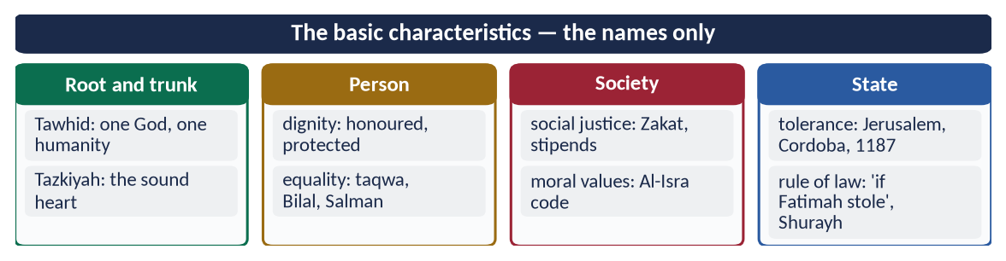
Figure 6 · At a glance — the basic characteristics — the names only. The detail is in the sections above.

(11) Conclusion
✦ QURAN
﴿… كَلِمَةٗ طَيِّبَةٗ كَشَجَرَةٖ طَيِّبَةٍ أَصۡلُهَا ثَابِتٞ وَفَرۡعُهَا فِي ٱلسَّمَآءِ ۝ تُؤۡتِيٓ أُكُلَهَا كُلَّ حِينِۭ بِإِذۡنِ رَبِّهَاۗ …﴾
“A good word is like a good tree, whose root is firm and whose branches reach the sky; it gives its fruit at every time by the permission of its Lord.” (Ibrahim, Quran)
➜ A good tree: its root firm and its branches in the sky, bearing fruit at every season.

The basic characteristics of Islamic civilization are not separate virtues but one living tree: when the root (Tawhid) and trunk (Tazkiyah) are sound, the branches of dignity, equality, justice, morality, tolerance and law grow by themselves. The decline of Muslims came when the trunk weakened; revival must begin there.

Why this answer scores
- It uses the syllabus's own eight characteristics as headings — the examiner's own list.
- Each has meaning + Quran/Hadith + a historical example — 'in detail'.
- The tree figure gives one memorable structure.

Answer 3 · The Moral Value System of Islam as a Feature of Islamic Civilization (CSS 2019)
THE QUESTION · CSS 2019 · Q5 · 20 marks
Throw light in detail on the moral value system of Islam as a significant feature of Islamic civilization.

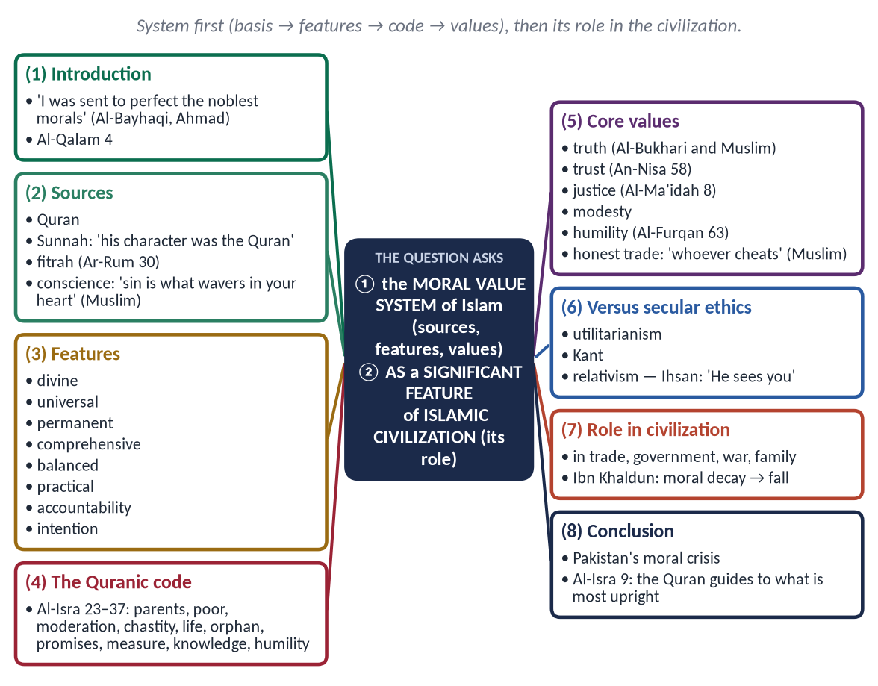
Figure 7 · The answer map: every branch is one numbered heading of the model answer below.

Decoding the question
- 'Moral value system' — not a list of good deeds only: its sources, features and core values as a system.
- 'As a significant feature of Islamic civilization' — show how morality shaped the civilization.
- 'In detail' — tables and examples.

The model answer

(1) Introduction
✦ HADITH
إِنَّمَا بُعِثْتُ لِأُتَمِّمَ مَكَارِمَ الْأَخْلَاقِ
“I was sent only to perfect the noblest morals.” (Al-Bayhaqi and Ahmad)
➜ Morality is the purpose of the prophetic mission.

✦ QURAN
﴿وَإِنَّكَ لَعَلَىٰ خُلُقٍ عَظِيمٖ﴾
“And indeed, you are of a great moral character.” (Al-Qalam, Quran)
➜ 'You are of a great moral character.'

Every civilization has laws; Islamic civilization made morality the spirit of its laws. Its moral system is divine in source, universal in scope and practical in application.

(2) The sources of Islamic morality
- The Quran — the moral law.
- The Sunnah — the moral model: 'his character was the Quran' (Muslim).
- Fitrah — the sound nature (Ar-Rum 30).
- Conscience:
✦ HADITH
الْبِرُّ حُسْنُ الْخُلُقِ، وَالْإِثْمُ مَا حَاكَ فِي صَدْرِكَ، وَكَرِهْتَ أَنْ يَطَّلِعَ عَلَيْهِ النَّاسُ
“Righteousness is good character, and sin is what wavers in your heart and you dislike people to know of it.” (Muslim)

(3) The features of the moral system
Feature | Meaning
Divine | Based on revelation, not changing opinion
Universal | Same for ruler and ruled, Muslim and non-Muslim
Permanent | Truth always good, lying always evil
Comprehensive | Individual, family, trade, politics, war, environment
Balanced | Body and soul, world and Hereafter, rights and duties
Practical | Within capacity (Al-Baqarah 286); lived by the Prophet ﷺ
Accountability | 'An atom's weight of good … of evil' (Az-Zalzalah 7–8)
Intention and act | 'Actions are by intentions' (Al-Bukhari and Muslim)

(4) The Quranic moral code — Surah Al-Isra (17:23–37)
✦ QURAN
﴿وَقَضَىٰ رَبُّكَ أَلَّا تَعۡبُدُوٓاْ إِلَّآ إِيَّاهُ وَبِٱلۡوَٰلِدَيۡنِ إِحۡسَٰنًاۚ إِمَّا يَبۡلُغَنَّ عِندَكَ ٱلۡكِبَرَ أَحَدُهُمَآ أَوۡ كِلَاهُمَا فَلَا تَقُل لَّهُمَآ أُفّٖ وَلَا تَنۡهَرۡهُمَا وَقُل لَّهُمَا قَوۡلٗا كَرِيمٗا﴾
“Your Lord has decreed that you worship none but Him, and that you be good to parents. If one or both of them reach old age with you, do not say to them even 'uff', nor repel them, but speak to them a noble word.” (Al-Isra, Quran)
➜ Worship none but Allah and be good to parents — not even 'uff'.

Then: give the relative, the poor and the traveller their due; do not squander; be moderate; do not kill your children for fear of poverty; do not approach zina; do not kill unjustly; guard the orphan's property; fulfil every commitment; give full measure; do not follow what you do not know; do not walk proudly on the earth.

(5) The core moral values

(i) Truthfulness
✦ HADITH
إِنَّ الصِّدْقَ يَهْدِي إِلَى الْبِرِّ، وَإِنَّ الْبِرَّ يَهْدِي إِلَى الْجَنَّةِ
“Truthfulness leads to righteousness, and righteousness leads to Paradise.” (Al-Bukhari and Muslim)

(ii) Trustworthiness and justice
✦ QURAN
﴿إِنَّ ٱللَّهَ يَأۡمُرُكُمۡ أَن تُؤَدُّواْ ٱلۡأَمَٰنَٰتِ إِلَىٰٓ أَهۡلِهَا وَإِذَا حَكَمۡتُم بَيۡنَ ٱلنَّاسِ أَن تَحۡكُمُواْ بِٱلۡعَدۡلِۚ إِنَّ ٱللَّهَ نِعِمَّا يَعِظُكُم بِهِۦٓۗ إِنَّ ٱللَّهَ كَانَ سَمِيعَۢا بَصِيرٗا﴾
“Indeed, Allah commands you to render trusts to whom they are due and when you judge between people to judge with justice. Excellent is that which Allah instructs you. Indeed, Allah is ever Hearing and Seeing.” (An-Nisa, Quran)
➜ Render trusts to whom they are due, and judge with justice.

✦ QURAN
﴿… وَلَا يَجۡرِمَنَّكُمۡ شَنَـَٔانُ قَوۡمٍ عَلَىٰٓ أَلَّا تَعۡدِلُواْۚ ٱعۡدِلُواْ هُوَ أَقۡرَبُ لِلتَّقۡوَىٰۖ …﴾
“Do not let the hatred of a people lead you to be unjust. Be just; that is nearer to righteousness.” (Al-Ma'idah, Quran)
➜ Do not let hatred lead you to injustice — justice is nearer to taqwa.

(iii) Modesty and chastity
'Modesty is a branch of faith' (Al-Bukhari and Muslim); lowering the gaze for men and women (An-Nur 30–31).

(iv) Humility and forbearance
✦ QURAN
﴿وَعِبَادُ ٱلرَّحۡمَٰنِ ٱلَّذِينَ يَمۡشُونَ عَلَى ٱلۡأَرۡضِ هَوۡنٗا وَإِذَا خَاطَبَهُمُ ٱلۡجَٰهِلُونَ قَالُواْ سَلَٰمٗا﴾
“And the servants of the Most Merciful are those who walk upon the earth easily, and when the ignorant address them [harshly], they say [words of] peace.” (Al-Furqan, Quran)
➜ The servants of the Most Merciful walk humbly, and answer the ignorant with 'Peace'.

(v) Honesty in business
✦ HADITH
مَنْ غَشَّ فَلَيْسَ مِنِّي
“Whoever cheats is not one of us.” (Muslim)

(vi) Social morals
Rights of neighbours, respect for elders, mercy to the young, care of orphans, keeping promises, forgiveness.

(6) Islamic morality and secular ethics
Question | Secular ethics | Islamic ethics
Source | Reason, utility, agreement | Revelation, confirmed by reason and fitrah
Standard | Relative | Fixed principles, flexible application
Motive | Utility (Bentham, Mill) / duty (Kant) | Allah's pleasure, with duty and benefit
Sanction | Law and opinion | Law, conscience, Hereafter
Private life | Largely free | Morality in private and public

The decisive difference is Ihsan — 'if you do not see Him, He sees you' (Muslim): Islamic morality works when no one is watching.

(7) Morality as a significant feature of Islamic civilization
- In trade: the muhtasib inspected weights and measures; honest Muslim traders carried Islam to Indonesia and East Africa.
- In government: Umar (RA) audited his governors; Umar ibn Abd al-Aziz returned the family's wealth to the treasury.
- In war: no women, children, monks or fruit trees to be harmed (Muslim; Muwatta).
- In the family: rights of parents, spouses and children.
- In knowledge: the scholar's integrity — the science of Hadith rejected any narrator known to lie.
✦ SCHOLARLY VIEW
Ibn Khaldun · Al-Muqaddimah
Luxury and injustice weaken a people's solidarity and bring the fall of dynasties — civilizations die morally before they die politically.
➜ Morality is the life of a civilization.

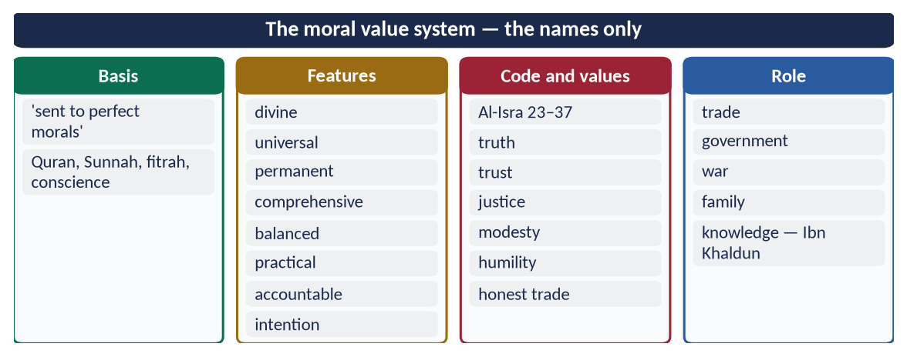
Figure 8 · At a glance — the moral value system — the names only. The detail is in the sections above.

(8) Conclusion
✦ QURAN
﴿إِنَّ هَٰذَا ٱلۡقُرۡءَانَ يَهۡدِي لِلَّتِي هِيَ أَقۡوَمُ وَيُبَشِّرُ ٱلۡمُؤۡمِنِينَ ٱلَّذِينَ يَعۡمَلُونَ ٱلصَّـٰلِحَٰتِ أَنَّ لَهُمۡ أَجۡرٗا كَبِيرٗا﴾
“Indeed, this Qur'an guides to that which is most suitable and gives good tidings to the believers who do righteous deeds that they will have a great reward.” (Al-Isra, Quran)
➜ 'This Quran guides to that which is most upright.'

The moral value system of Islam — divine, universal, balanced and enforced by conscience — was the soul of Islamic civilization, shaping its markets, courts, armies and homes. Pakistan's crisis of corruption and dishonesty is at root a moral crisis; its solution is the revival of this system.

Why this answer scores
- It presents morality as a system — sources, features, code, values — not a random list.
- It shows its role in the civilization — the second limb.
- The comparison with secular ethics adds analytical depth.

Answer 4 · Self-Purification in the Quran and Sunnah and Its Impact on Society (CSS 2017)
THE QUESTION · CSS 2017 · Q6 · 20 marks
Explain the concept of self-purification in the light of the Qur'ān and Sunnah and its impact on society.

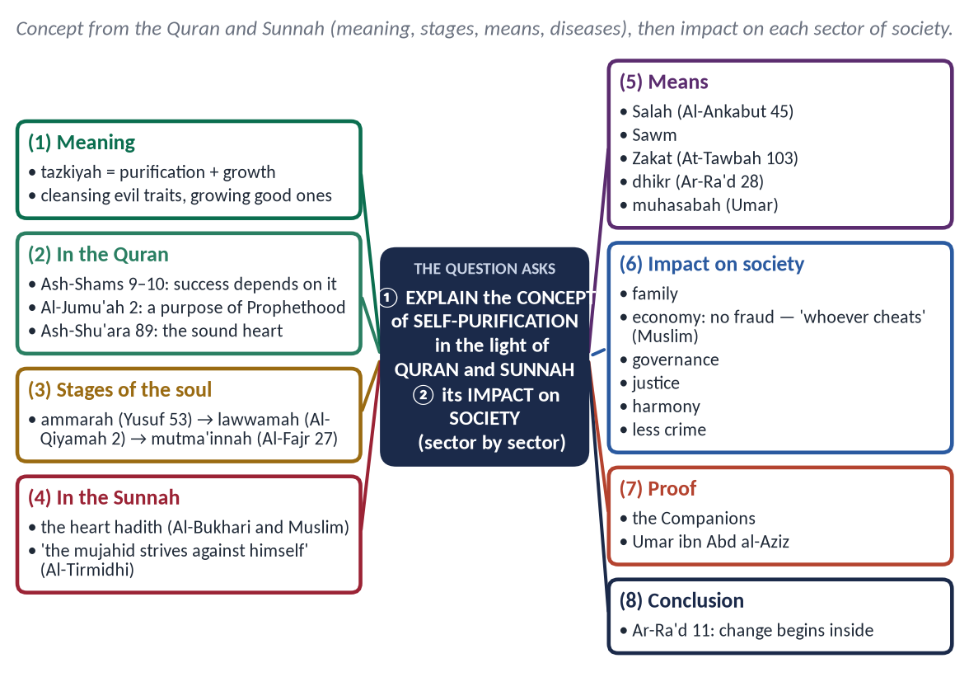
Figure 9 · The answer map: every branch is one numbered heading of the model answer below.

Decoding the question
- 'Concept in the light of the Quran and Sunnah' — meaning, stages, means and obstacles, each from the texts.
- 'Its impact on society' — the second limb; organise by sectors of society.

The model answer

(1) Introduction
✦ QURAN
﴿قَدۡ أَفۡلَحَ مَن زَكَّىٰهَا ۝ وَقَدۡ خَابَ مَن دَسَّىٰهَا﴾
“He has succeeded who purifies it. And he has failed who instills it [with corruption].” (Ash-Shams, Quran)
➜ 'He has succeeded who purifies it, and he has failed who corrupts it.'

Society is only the sum of its individuals. Laws can punish crime; only a purified heart can prevent it. That is why the Quran made tazkiyah one of the four functions of the Prophet ﷺ and the key to success.

(2) The concept of self-purification
Tazkiyah (تَزْكِيَة) means purification and growth. Tazkiyat al-nafs is cleansing the self of evil traits — pride, envy, greed, hypocrisy — and growing good ones — sincerity, patience, gratitude, humility — so that one obeys Allah willingly with a sound heart.

(3) Self-purification in the Quran
- The key to success: Ash-Shams 9–10 (above); 'he has certainly succeeded who purifies himself' (Al-A'la 14).
- A purpose of the Prophethood:
✦ QURAN
﴿هُوَ ٱلَّذِي بَعَثَ فِي ٱلۡأُمِّيِّـۧنَ رَسُولٗا مِّنۡهُمۡ يَتۡلُواْ عَلَيۡهِمۡ ءَايَٰتِهِۦ وَيُزَكِّيهِمۡ وَيُعَلِّمُهُمُ ٱلۡكِتَٰبَ وَٱلۡحِكۡمَةَ وَإِن كَانُواْ مِن قَبۡلُ لَفِي ضَلَٰلٖ مُّبِينٖ﴾
“It is He who has sent among the unlettered a Messenger from themselves reciting to them His verses and purifying them and teaching them the Book and wisdom - although they were before in clear error.” (Al-Jumu'ah, Quran)
➜ The Messenger recites His verses, purifies them and teaches them the Book and wisdom.

- The sound heart:
✦ QURAN
﴿يَوۡمَ لَا يَنفَعُ مَالٞ وَلَا بَنُونَ ۝ إِلَّا مَنۡ أَتَى ٱللَّهَ بِقَلۡبٖ سَلِيمٖ﴾
“The Day when there will not benefit [anyone] wealth or children. But only one who comes to Allah with a sound heart.” (Ash-Shu'ara, Quran)
➜ Wealth and sons will not benefit — except one who comes to Allah with a sound heart.

- The stages of the soul:
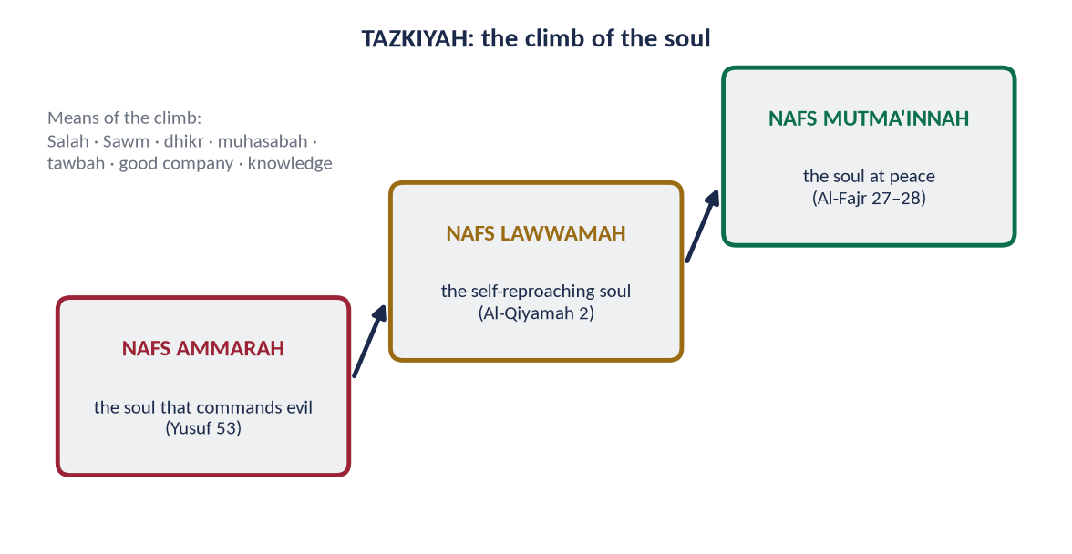
Figure 10 · The soul's climb from ammarah to mutma'innah.

(4) Self-purification in the Sunnah
✦ HADITH
أَلَا وَإِنَّ فِي الْجَسَدِ مُضْغَةً إِذَا صَلَحَتْ صَلَحَ الْجَسَدُ كُلُّهُ، وَإِذَا فَسَدَتْ فَسَدَ الْجَسَدُ كُلُّهُ، أَلَا وَهِيَ الْقَلْبُ
“In the body is a piece of flesh; if it is sound, the whole body is sound; if it is corrupt, the whole body is corrupt — it is the heart.” (Al-Bukhari and Muslim)

✦ HADITH
الْمُجَاهِدُ مَنْ جَاهَدَ نَفْسَهُ
“The true mujahid is the one who strives against his own self.” (Al-Tirmidhi)

✦ HADITH
لَا يَدْخُلُ الْجَنَّةَ مَنْ كَانَ فِي قَلْبِهِ مِثْقَالُ ذَرَّةٍ مِنْ كِبْرٍ
“No one with an atom's weight of pride in his heart will enter Paradise.” (Muslim)
➜ Pride — the first disease to be removed.

(5) The means of self-purification
Means | Evidence
Salah | Restrains from indecency and wrongdoing (Al-Ankabut 45)
Sawm | 'That you may attain taqwa' (Al-Baqarah 183)
Zakat | 'Take from their wealth a charity to purify them' (At-Tawbah 103)
Dhikr | 'In the remembrance of Allah hearts find rest' (Ar-Ra'd 28)
Muhasabah | 'Take account of yourselves before you are taken to account' — Umar (RA)
Good company | 'Be with the truthful' (At-Tawbah 119)

(6) The impact of self-purification on society

(i) On the family
Patience, forgiveness and fulfilment of rights replace quarrels; children learn character from purified parents.

(ii) On the economy
✦ HADITH
مَنْ غَشَّ فَلَيْسَ مِنِّي
“Whoever cheats is not one of us.” (Muslim)

The purified trader does not adulterate, hoard or deal in riba; the rich give Zakat willingly.

(iii) On governance
Officials who fear Allah do not take bribes; rulers become servants. Umar (RA) said that if a mule stumbled on a road in Iraq, he feared Allah would ask him why he had not levelled the road.

(iv) On justice
Witnesses speak the truth 'even against themselves' (An-Nisa 135); judges fear the Fire more than the powerful.

(v) On social harmony
No envy, backbiting or arrogance → trust, brotherhood and peace.

(vi) On crime
Inner restraint prevents crime where police cannot reach — the soul's lawwamah (conscience) does the policing.
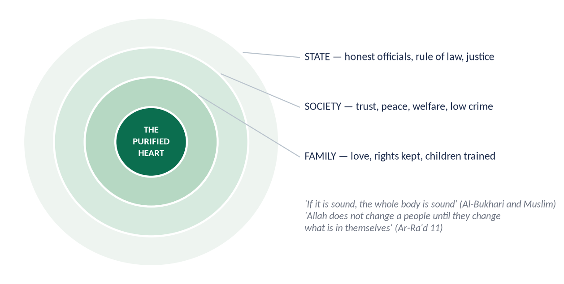
Figure 11 · From the purified heart to family, society and state.

(7) The proof in history
The Companions, purified by the Prophet ﷺ, turned the most lawless society of Arabia into the most just. Two years of Umar ibn Abd al-Aziz (717–720), a ruler who purified himself first, produced a society where no one would take Zakat.

(8) Conclusion
✦ QURAN
﴿… إِنَّ ٱللَّهَ لَا يُغَيِّرُ مَا بِقَوۡمٍ حَتَّىٰ يُغَيِّرُواْ مَا بِأَنفُسِهِمۡۗ …﴾
“Indeed, Allah will not change the condition of a people until they change what is in themselves.” (Ar-Ra'd, Quran)
➜ Allah does not change the condition of a people until they change what is in themselves.

Self-purification, taught by the Quran and practised in the Sunnah, is not a private spiritual exercise but the foundation of social reform. Pakistan's problems of corruption and injustice will not be solved by laws alone; they need purified individuals.

Why this answer scores
- The concept is proved from both Quran and Sunnah, as asked.
- The impact is shown sector by sector — family, economy, governance, justice, harmony, crime.
- Two figures and a historical proof support the argument.

Answer 5 · Self-Purification and Ihsan: Their Individual and Collective Impacts (CSS 2018)
THE QUESTION · CSS 2018 · Q3 · 20 marks
What is Self-purification and Ehsan? Explain it in the light of Quran and Sunnah, also describe its individual and collective impacts.

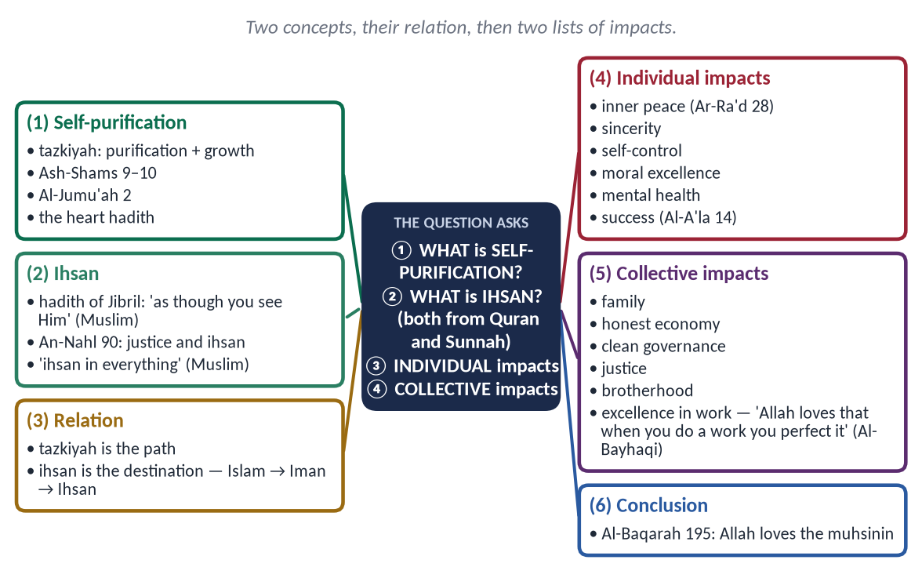
Figure 12 · The answer map: every branch is one numbered heading of the model answer below.

Decoding the question
- Two concepts — self-purification and Ihsan — each defined and proved separately.
- Individual and collective impacts — two separate headings.

The model answer

(1) Introduction
Islam is not only a set of rituals but a transformation of the person. Two Quranic concepts describe this transformation: tazkiyah — the process of purifying the self — and ihsan — the excellence it reaches.

(2) What is self-purification?
Tazkiyah (تَزْكِيَة) — purification and growth: removing pride, envy, greed and showing off; growing sincerity, patience, gratitude and humility.
✦ QURAN
﴿قَدۡ أَفۡلَحَ مَن زَكَّىٰهَا ۝ وَقَدۡ خَابَ مَن دَسَّىٰهَا﴾
“He has succeeded who purifies it. And he has failed who instills it [with corruption].” (Ash-Shams, Quran)
➜ 'He has succeeded who purifies it, and he has failed who corrupts it.'

✦ QURAN
﴿هُوَ ٱلَّذِي بَعَثَ فِي ٱلۡأُمِّيِّـۧنَ رَسُولٗا مِّنۡهُمۡ يَتۡلُواْ عَلَيۡهِمۡ ءَايَٰتِهِۦ وَيُزَكِّيهِمۡ وَيُعَلِّمُهُمُ ٱلۡكِتَٰبَ وَٱلۡحِكۡمَةَ وَإِن كَانُواْ مِن قَبۡلُ لَفِي ضَلَٰلٖ مُّبِينٖ﴾
“It is He who has sent among the unlettered a Messenger from themselves reciting to them His verses and purifying them and teaching them the Book and wisdom - although they were before in clear error.” (Al-Jumu'ah, Quran)
➜ The Messenger purifies them (yuzakkihim) — one of his four functions.

✦ HADITH
أَلَا وَإِنَّ فِي الْجَسَدِ مُضْغَةً ... أَلَا وَهِيَ الْقَلْبُ
“In the body is a piece of flesh … it is the heart.” (Al-Bukhari and Muslim)
➜ Purification is of the heart.

(3) What is Ihsan?
Ihsan (إِحْسَان) — from husn, beauty — means excellence: doing everything in the most beautiful way.

(i) Ihsan towards Allah
✦ HADITH
أَنْ تَعْبُدَ اللَّهَ كَأَنَّكَ تَرَاهُ، فَإِنْ لَمْ تَكُنْ تَرَاهُ فَإِنَّهُ يَرَاكَ
“That you worship Allah as though you see Him; and if you do not see Him, He certainly sees you.” (Muslim)
➜ The answer to Jibril — the highest level of the religion.

(ii) Ihsan towards people
✦ QURAN
﴿إِنَّ ٱللَّهَ يَأۡمُرُ بِٱلۡعَدۡلِ وَٱلۡإِحۡسَٰنِ وَإِيتَآيِٕ ذِي ٱلۡقُرۡبَىٰ وَيَنۡهَىٰ عَنِ ٱلۡفَحۡشَآءِ وَٱلۡمُنكَرِ وَٱلۡبَغۡيِۚ يَعِظُكُمۡ لَعَلَّكُمۡ تَذَكَّرُونَ﴾
“Indeed, Allah orders justice and good conduct and giving to relatives and forbids immorality and bad conduct and oppression. He admonishes you that perhaps you will be reminded.” (An-Nahl, Quran)
➜ Allah commands justice ('adl) and excellence (ihsan) — ihsan is giving more than justice requires.

✦ HADITH
إِنَّ اللَّهَ كَتَبَ الْإِحْسَانَ عَلَى كُلِّ شَيْءٍ
“Allah has prescribed excellence in everything.” (Muslim)
➜ Even in slaughtering an animal — sharpen the blade, spare it suffering.

(iii) The three levels of the religion
Islam (the outward acts) → Iman (the inner beliefs) → Ihsan (the quality of both).

(4) The relation between the two
Tazkiyah is the path; Ihsan is the destination. The more the heart is purified, the more the servant lives 'as though he sees Allah'. Both are the subject of Imam al-Ghazali's *Ihya'*, whose last two quarters treat the destroyers and the saviours of the heart.

(5) The individual impacts
- (a) Inner peace: 'in the remembrance of Allah hearts find rest' (Ar-Ra'd 28).
- (b) Sincerity: the same person in private and public — because 'He sees you'.
- (c) Self-control: over anger, desire and greed (An-Nazi'at 40–41).
- (d) Moral excellence: truthfulness, humility, patience, generosity.
- (e) Mental health: freedom from envy, anxiety, arrogance and despair.
- (f) Excellence in work: doing one's job as worship.
- (g) Success in both worlds:
✦ QURAN
﴿قَدۡ أَفۡلَحَ مَن تَزَكَّىٰ﴾
“He has certainly succeeded who purifies himself.” (Al-A'la, Quran)
➜ 'He has certainly succeeded who purifies himself.'

(6) The collective impacts
- (a) The family: rights fulfilled with ihsan — more than the minimum.
- (b) The economy: honest trade, fair wages, generosity; no fraud or riba.
- (c) Governance: officials who feel watched by Allah are not corrupt.
- (d) Justice: truthful witnesses and fair judges.
- (e) Brotherhood: 'none of you believes until he loves for his brother what he loves for himself' (Al-Bukhari and Muslim).
- (f) A culture of quality:
✦ HADITH
إِنَّ اللَّهَ يُحِبُّ إِذَا عَمِلَ أَحَدُكُمْ عَمَلًا أَنْ يُتْقِنَهُ
“Allah loves that when one of you does a work, he does it with excellence.” (Al-Bayhaqi)
➜ Ihsan becomes a national work ethic.

- (g) Peace and trust: less crime, less litigation, more cooperation.
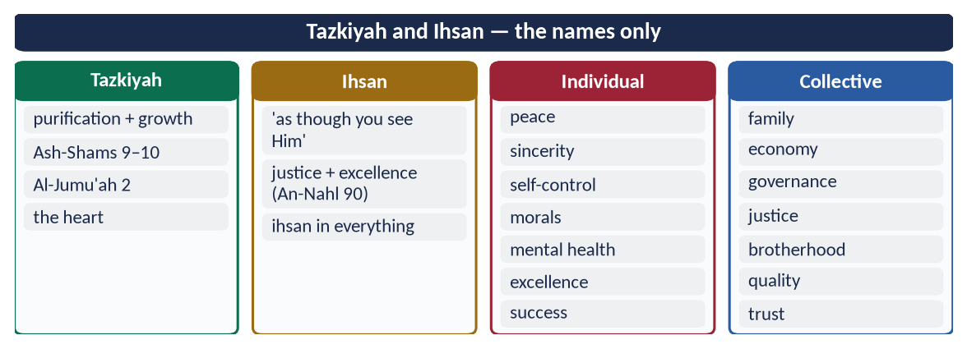
Figure 13 · At a glance — tazkiyah and Ihsan — the names only. The detail is in the sections above.

(7) Conclusion
✦ QURAN
﴿وَأَنفِقُواْ فِي سَبِيلِ ٱللَّهِ وَلَا تُلۡقُواْ بِأَيۡدِيكُمۡ إِلَى ٱلتَّهۡلُكَةِ وَأَحۡسِنُوٓاْۚ إِنَّ ٱللَّهَ يُحِبُّ ٱلۡمُحۡسِنِينَ﴾
“And spend in the way of Allah and do not throw [yourselves] with your [own] hands into destruction [by refraining]. And do good; indeed, Allah loves the doers of good.” (Al-Baqarah, Quran)
➜ 'Do good (ahsinu); indeed, Allah loves the doers of good.'

Tazkiyah purifies the heart; Ihsan makes every act excellent. Together they produce a person who is honest when unwatched and a society that works with trust and quality — the goal of the Islamic civilization.

Why this answer scores
- Two concepts, two definitions, each from the Quran and Sunnah.
- The relation between them shows understanding.
- Individual and collective impacts in separate headings, as asked.

Answer 6 · Self-Purification: An Essential Element for the Evolution of Society (CSS 2024)
THE QUESTION · CSS 2024 · Q2 · 20 marks
Self-purification is an essential element for the evolution of society. Explain.

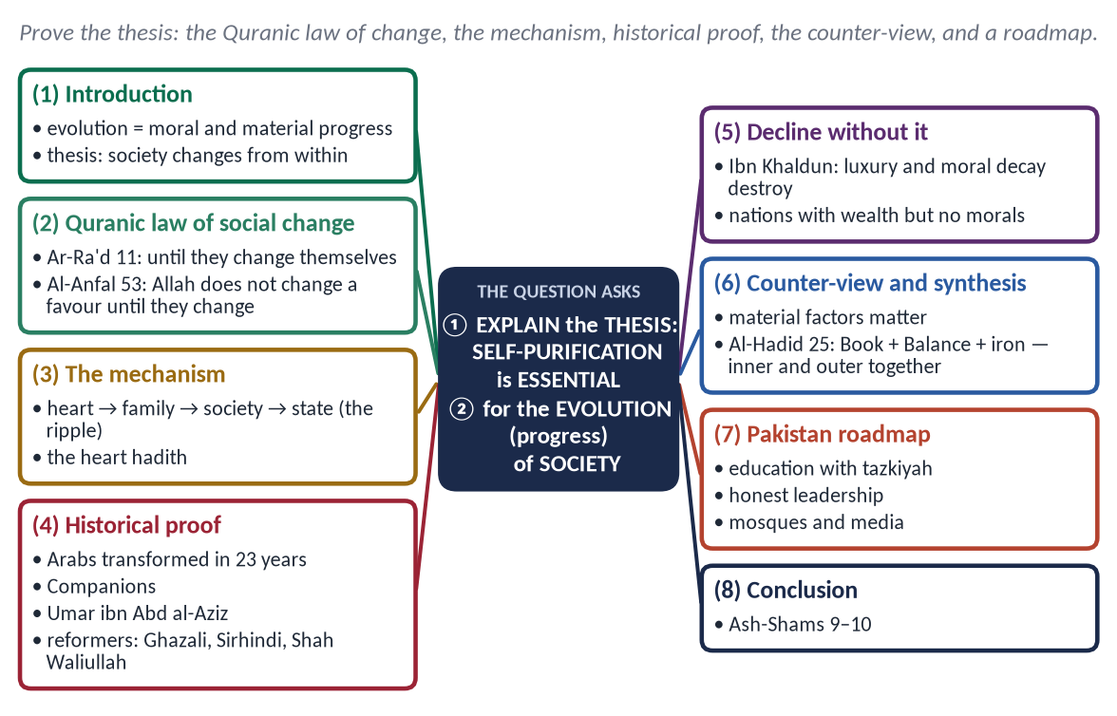
Figure 14 · The answer map: every branch is one numbered heading of the model answer below.

Decoding the question
- A thesis to explain: prove why self-purification is essential for social progress.
- 'Evolution of society' = moral, social and material progress over time.
- Strong answers include the counter-view (material and structural factors) and a synthesis.

The model answer

(1) Introduction
Societies evolve — from tribe to state, from ignorance to knowledge, from injustice to justice. Modern theories stress economics, technology and institutions. Islam accepts these but insists that the decisive factor is inner: a society rises when its people are purified and falls when they are corrupted. Self-purification — tazkiyah (تَزْكِيَة) — is therefore essential, not optional.

(2) The Quranic law of social change
✦ QURAN
﴿… إِنَّ ٱللَّهَ لَا يُغَيِّرُ مَا بِقَوۡمٍ حَتَّىٰ يُغَيِّرُواْ مَا بِأَنفُسِهِمۡۗ …﴾
“Indeed, Allah will not change the condition of a people until they change what is in themselves.” (Ar-Ra'd, Quran)
➜ Allah does not change the condition of a people until they change what is in themselves.

✦ QURAN
﴿ذَٰلِكَ بِأَنَّ ٱللَّهَ لَمۡ يَكُ مُغَيِّرٗا نِّعۡمَةً أَنۡعَمَهَا عَلَىٰ قَوۡمٍ حَتَّىٰ يُغَيِّرُواْ مَا بِأَنفُسِهِمۡ وَأَنَّ ٱللَّهَ سَمِيعٌ عَلِيمٞ﴾
“That is because Allah would not change a favor which He had bestowed upon a people until they change what is within themselves. And indeed, Allah is Hearing and Knowing.” (Al-Anfal, Quran)
➜ Allah would not change a favour He had bestowed on a people until they change what is within themselves.

The Quran states a law: outer change follows inner change — in rise and in fall.

(3) The mechanism — from the heart to the civilization
✦ HADITH
أَلَا وَإِنَّ فِي الْجَسَدِ مُضْغَةً إِذَا صَلَحَتْ صَلَحَ الْجَسَدُ كُلُّهُ ... أَلَا وَهِيَ الْقَلْبُ
“If the heart is sound, the whole body is sound.” (Al-Bukhari and Muslim)

Figure 15 · The ripple of tazkiyah: heart → family → society → state.
- Heart → person: honesty, discipline, self-control.
- Person → family: rights kept, children raised with character.
- Family → society: trust, cooperation, low crime.
- Society → state: honest officials, just laws, public trust — the conditions of economic and scientific progress.

(4) The historical proof
- (a) The Arabs: in twenty-three years, a people of blood feuds, drinking and infanticide became the builders of a civilization — because the Prophet ﷺ purified them first (Al-Jumu'ah 2).
✦ QURAN
﴿وَٱعۡتَصِمُواْ بِحَبۡلِ ٱللَّهِ جَمِيعٗا وَلَا تَفَرَّقُواْۚ وَٱذۡكُرُواْ نِعۡمَتَ ٱللَّهِ عَلَيۡكُمۡ إِذۡ كُنتُمۡ أَعۡدَآءٗ فَأَلَّفَ بَيۡنَ قُلُوبِكُمۡ فَأَصۡبَحۡتُم بِنِعۡمَتِهِۦٓ إِخۡوَٰنٗا …﴾
“And hold firmly to the rope of Allah all together and do not become divided. Remember Allah's favour upon you: you were enemies, and He brought your hearts together, and by His favour you became brothers.” (Aal-e-Imran, Quran)
➜ 'You were enemies and He joined your hearts, and you became brothers.'

- (b) The Companions: rulers like Umar and Abu Ubaydah lived simply and governed justly.
- (c) Umar ibn Abd al-Aziz (717–720): a ruler who purified himself first — and in two years no one could be found to take Zakat.
- (d) The reformers: Imam al-Ghazali revived society through the Ihya'; Shaykh Ahmad Sirhindi and Shah Waliullah reformed the subcontinent by reforming hearts and minds.

(5) Decline without self-purification
✦ SCHOLARLY VIEW
Ibn Khaldun · Al-Muqaddimah
When a people sink into luxury, their solidarity and courage weaken, injustice spreads and their state falls — often within three or four generations.
➜ Moral decay precedes political decline.

Baghdad fell in 1258 and Muslim Spain in 1492 after long periods of luxury and internal division. Today, some rich nations suffer from family breakdown, addiction and loneliness — material progress without purification.

(6) The counter-view and the Islamic synthesis
Some argue that society evolves through economic and structural change — technology, markets, institutions. Islam agrees that these matter, but joins them to inner change:
✦ QURAN
﴿لَقَدۡ أَرۡسَلۡنَا رُسُلَنَا بِٱلۡبَيِّنَٰتِ وَأَنزَلۡنَا مَعَهُمُ ٱلۡكِتَٰبَ وَٱلۡمِيزَانَ لِيَقُومَ ٱلنَّاسُ بِٱلۡقِسۡطِۖ …﴾
“We sent Our messengers with clear proofs and sent down with them the Book and the Balance, so that people may uphold justice.” (Al-Hadid, Quran)
➜ We sent the messengers with the Book and the Balance so that people may uphold justice, and We sent down iron, with great strength and benefits.

The Book (guidance and purification), the Balance (justice and institutions) and iron (power and technology) together — but the Book comes first.

(7) A roadmap for Pakistan
- Education: character (tazkiyah) taught with information — 'recite, purify, teach'.
- Leadership: rulers and officials who model honesty.
- Mosques and media: Friday sermons and programmes on honesty, punctuality and public duty.
- Family: parents as models.
- Law and institutions: accountability to support, not replace, the inner police.
Pakistan's rank of 135th of 180 in the Corruption Perceptions Index 2024 shows that laws without purified people do not work.
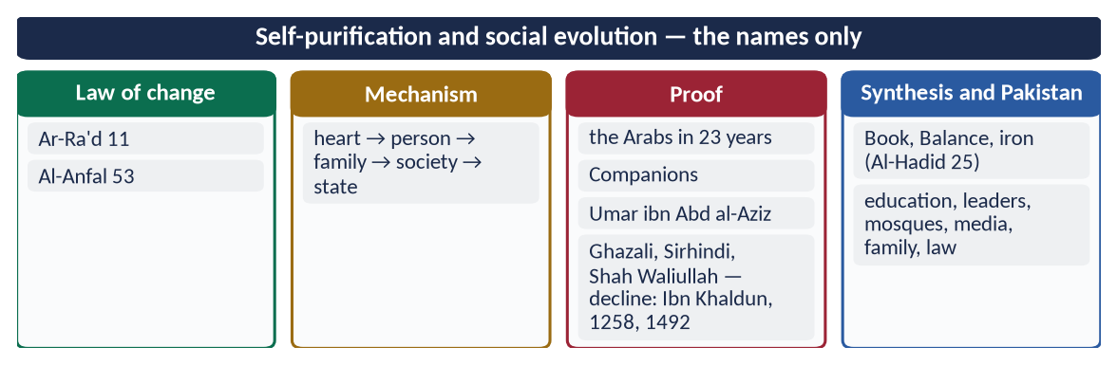
Figure 16 · At a glance — self-purification and social evolution — the names only. The detail is in the sections above.

(8) Conclusion
✦ QURAN
﴿قَدۡ أَفۡلَحَ مَن زَكَّىٰهَا ۝ وَقَدۡ خَابَ مَن دَسَّىٰهَا﴾
“He has succeeded who purifies it. And he has failed who instills it [with corruption].” (Ash-Shams, Quran)
➜ 'He has succeeded who purifies it, and he has failed who corrupts it.'

The Quranic law, the mechanism of the heart and the evidence of history all point to one truth: society evolves from within. Economic and institutional reform are necessary, but without self-purification they fail. Tazkiyah is therefore not merely helpful but essential for the evolution of any society — and most of all for ours.

Why this answer scores
- It treats the question as a thesis and proves it with law, mechanism, history and counter-argument.
- The synthesis (Al-Hadid 25) shows balanced thinking.
- The Pakistan roadmap makes it practical.

Answer 7 · Sufism and the Spread of Islam; Can It Reform Today's Deviations? (CSS 2021)
THE QUESTION · CSS 2021 · Q7 · 20 marks
Explore the importance of Sufism to spread out Islam. Is the amelioration of current deviation possible through Sufism?

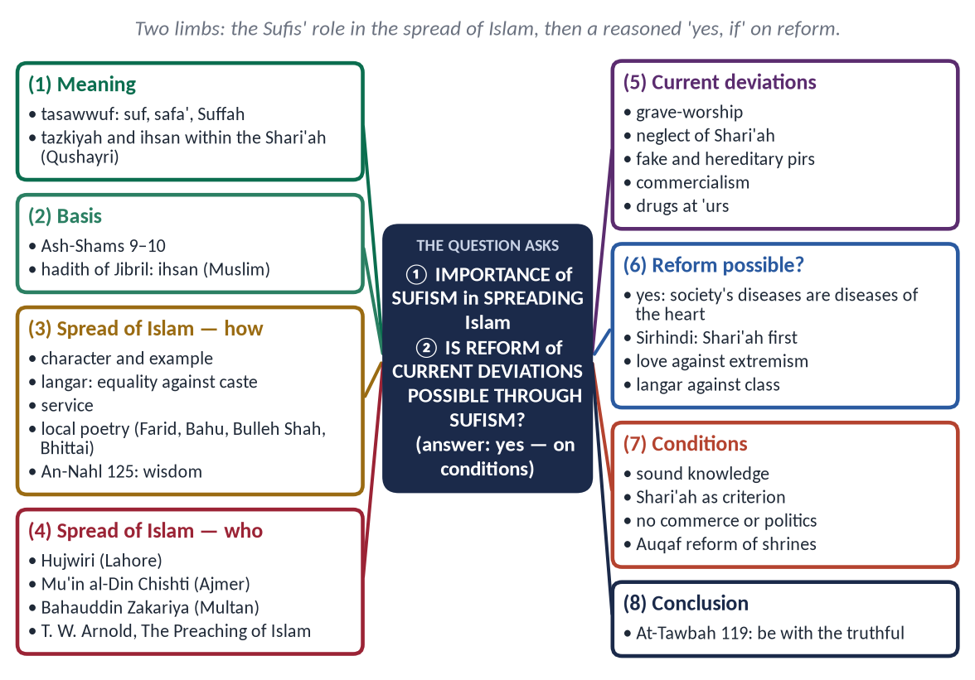
Figure 17 · The answer map: every branch is one numbered heading of the model answer below.

Decoding the question
- 'Explore the importance of Sufism to spread Islam' — how and by whom Islam spread through the Sufis (especially in the subcontinent).
- 'Is the amelioration of current deviation possible through Sufism?' — a judgement: give a reasoned 'yes, on conditions', and identify the deviations — including those within shrine culture.
- Stay non-sectarian: criticise practices, not schools.

The model answer

(1) Introduction
Tasawwuf (تَصَوُّف) — Sufism — is the Muslim science of the heart: the practical path of tazkiyah and ihsan. In the subcontinent, where the majority of Muslims today live, Islam spread above all through the Sufis. The same tradition, returned to its roots, can help cure the moral and social deviations of our time.

(2) The meaning and basis of Sufism
- The word: linked to suf (wool — the simple dress of the ascetics), safa' (purity) or the Ahl al-Suffah.
- The basis:
✦ QURAN
﴿قَدۡ أَفۡلَحَ مَن زَكَّىٰهَا ۝ وَقَدۡ خَابَ مَن دَسَّىٰهَا﴾
“He has succeeded who purifies it. And he has failed who instills it [with corruption].” (Ash-Shams, Quran)
➜ 'He has succeeded who purifies it.'

✦ HADITH
أَنْ تَعْبُدَ اللَّهَ كَأَنَّكَ تَرَاهُ، فَإِنْ لَمْ تَكُنْ تَرَاهُ فَإِنَّهُ يَرَاكَ
“Worship Allah as though you see Him; if you do not see Him, He sees you.” (Muslim)
➜ Ihsan — the goal of Sufism.

✦ SCHOLARLY VIEW
Imam al-Qushayri · Al-Risalah
Sufism is holding to the Quran and Sunnah, purifying the heart and adorning it with good character; any 'state' contrary to the Shari'ah is false.
➜ Sufism within the Shari'ah.

(3) The importance of Sufism in the spread of Islam
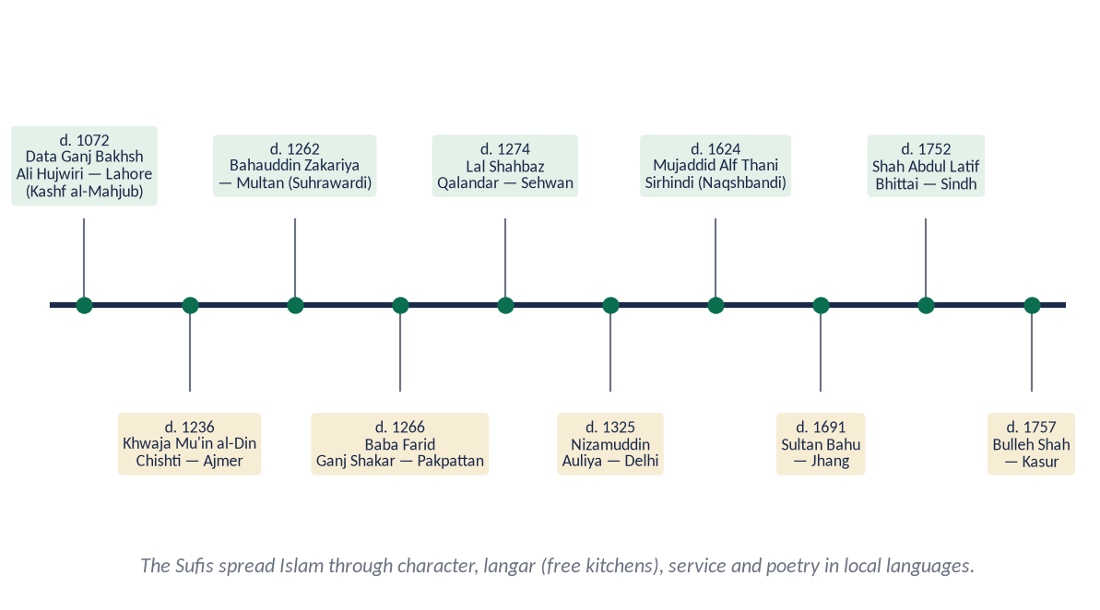
Figure 18 · The great Sufis of the subcontinent.

(i) The pioneers
- Data Ganj Bakhsh Ali Hujwiri (d. c. 1072), Lahore — Kashf al-Mahjub, the first Persian treatise on Sufism.
- Khwaja Mu'in al-Din Chishti (d. 1236), Ajmer — founder of the Chishti order in India.
- Shaykh Bahauddin Zakariya (d. 1262), Multan — the Suhrawardi order.
- Baba Farid (Pakpattan), Nizamuddin Auliya (Delhi), Lal Shahbaz Qalandar (Sehwan).

(ii) The methods
- (a) Character before preaching — their honesty, humility and generosity drew people.
✦ QURAN
﴿ٱدۡعُ إِلَىٰ سَبِيلِ رَبِّكَ بِٱلۡحِكۡمَةِ وَٱلۡمَوۡعِظَةِ ٱلۡحَسَنَةِۖ وَجَٰدِلۡهُم بِٱلَّتِي هِيَ أَحۡسَنُۚ …﴾
“Invite to the way of your Lord with wisdom and good instruction, and argue with them in the way that is best.” (An-Nahl, Quran)
➜ Invite with wisdom and good instruction — the Sufi way.

- (b) The langar — at their free kitchens, Brahmin and outcaste, rich and poor ate together; in a caste society this was a revolution of equality.
- (c) Service — feeding the hungry, sheltering travellers, nursing the sick.
- (d) Local languages and poetry — Punjabi (Baba Farid, Sultan Bahu, Bulleh Shah), Sindhi (Shah Abdul Latif Bhittai), Pashto (Rahman Baba) carried Islam into the heart in the people's own tongue.
- (e) The khanqah — a school of the Quran, adab and discipline.
- (f) No compulsion — people accepted Islam freely (Al-Baqarah 256).
✦ SCHOLARLY VIEW
Sir Thomas W. Arnold · The Preaching of Islam (1896)
Arnold showed that Islam spread in India and many other lands mainly through the peaceful preaching of traders and Sufis, not by force.
➜ A Western historian's evidence.

(iii) Reformers from within
Shaykh Ahmad Sirhindi (Mujaddid Alf Thani, d. 1624) opposed Akbar's Din-i-Ilahi and insisted that the Sufi path follow the Shari'ah; Shah Waliullah joined Sufism with Hadith and social reform.

(4) The current deviations
Deviation | Why it is rejected
Prostration and petitions at graves | Worship is for Allah alone (Al-Fatihah 5) — the Sufis taught Tawhid
Neglect of Salah and Shari'ah | 'No tariqah without Shari'ah' — Hujwiri, Sirhindi
Fake and hereditary pirs | Rank is by piety, not birth; exploitation of the poor
Commercialism and politics at shrines | Religion sold for money and votes
Drugs, dance at 'urs | Against the Shari'ah and Sufi discipline

Beyond the shrines, society suffers deeper deviations: corruption, materialism, sectarian hatred, extremism and loss of trust.

(5) Is reform possible through Sufism? — Yes, on conditions

(i) Why yes
- (a) The diseases are of the heart — greed, pride, envy, hatred — and Sufism is the science of the heart.
- (b) Love against extremism — the Sufi message of love and service is a proven antidote to sectarian violence; Sufi shrines have themselves been targets of extremists.
- (c) Equality against classism — the langar model.
- (d) History — Sirhindi and Shah Waliullah reformed their societies through reformed Sufism.

(ii) The conditions
- Sound knowledge and the Shari'ah as the criterion of every practice.
- Sincere guides, chosen for piety, not inheritance.
- No commerce or politics at shrines.
- State reform: the Auqaf department, which took over major shrines in 1960–61, can turn them into centres of Quran teaching, welfare and education — Data Darbar's langar and hospital show the way.
✦ QURAN
﴿يَـٰٓأَيُّهَا ٱلَّذِينَ ءَامَنُواْ ٱتَّقُواْ ٱللَّهَ وَكُونُواْ مَعَ ٱلصَّـٰدِقِينَ﴾
“O you who have believed, fear Allah and be with those who are true.” (At-Tawbah, Quran)
➜ 'Fear Allah and be with the truthful.'

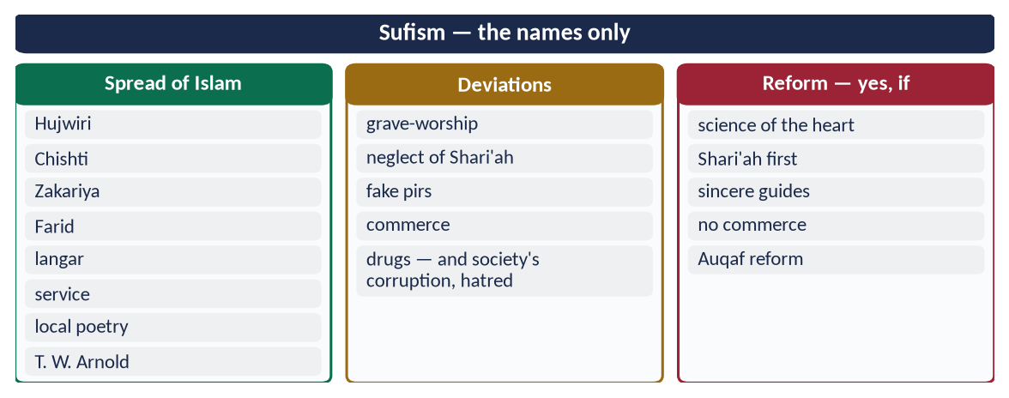
Figure 19 · At a glance — sufism — the names only. The detail is in the sections above.

(6) Conclusion
Sufism spread Islam across the subcontinent through character, equality, service and poetry. Its deviations are real, but they are betrayals of Sufism, not its essence. Returned to its roots — tazkiyah and ihsan under the Shari'ah, as Sirhindi taught — Sufism can indeed help heal the moral deviations of our society.

Why this answer scores
- Both limbs answered: importance (pioneers + methods + evidence) and a reasoned judgement on reform.
- Deviations are named without sectarian attack.
- The conditions and the Auqaf reform make the 'yes' credible.

Answer 8 · The Classist Lifestyle in the Light of Islam and Its Effects on Society (CSS 2025)
THE QUESTION · CSS 2025 · Q4 · 20 marks
Determine the status of the classist lifestyle in the light of the teachings of Islam and examine its effects on human society.

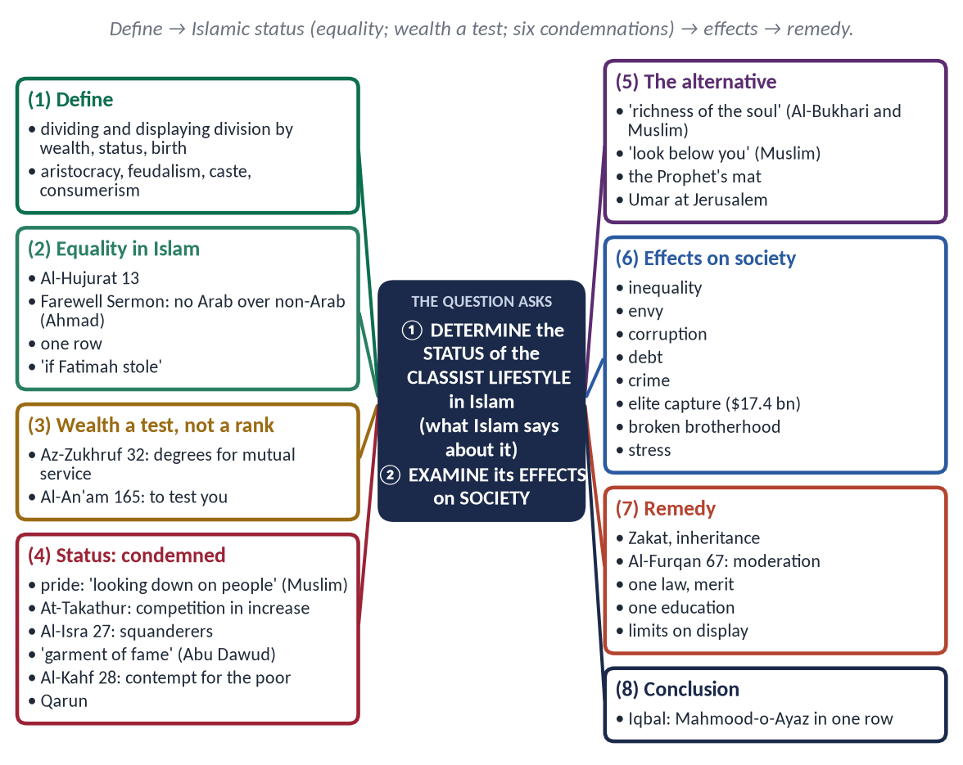
Figure 20 · The answer map: every branch is one numbered heading of the model answer below.

Decoding the question
- 'Determine the status … in the light of the teachings of Islam' — a clear ruling: Islam accepts differences of income but condemns pride, display and exploitation — prove it.
- 'Examine its effects on human society' — a balanced list of harms, with evidence (including Pakistani data).

The model answer

(1) Introduction
A classist lifestyle divides people by wealth, status or birth and displays that division — in houses, cars, schools, weddings and manners — while treating the poor as lesser humans. In history it took the form of aristocracy, feudalism and caste; today it appears as consumerism, VIP culture and elite privilege. Islam's verdict on it is clear.

(2) Islam's principle — the equality of all
✦ QURAN
﴿يَـٰٓأَيُّهَا ٱلنَّاسُ إِنَّا خَلَقۡنَٰكُم مِّن ذَكَرٖ وَأُنثَىٰ وَجَعَلۡنَٰكُمۡ شُعُوبٗا وَقَبَآئِلَ لِتَعَارَفُوٓاْۚ إِنَّ أَكۡرَمَكُمۡ عِندَ ٱللَّهِ أَتۡقَىٰكُمۡۚ إِنَّ ٱللَّهَ عَلِيمٌ خَبِيرٞ﴾
“O mankind, indeed We have created you from male and female and made you peoples and tribes that you may know one another. Indeed, the most noble of you in the sight of Allah is the most righteous of you. Indeed, Allah is Knowing and Acquainted.” (Al-Hujurat, Quran)
➜ Created from one pair, made into nations and tribes to know one another; the most honoured is the most righteous.

✦ FROM THE SIRAH
لَا فَضْلَ لِعَرَبِيٍّ عَلَى عَجَمِيٍّ، وَلَا لِعَجَمِيٍّ عَلَى عَرَبِيٍّ ... إِلَّا بِالتَّقْوَى
“No Arab has superiority over a non-Arab … except by taqwa.” (Musnad Ahmad (the Farewell Sermon))

One row in prayer, two sheets in Hajj, one law for the noble and the weak ('if Fatimah stole…').

(3) Differences in wealth — a test, not a rank
✦ QURAN
﴿… وَرَفَعۡنَا بَعۡضَهُمۡ فَوۡقَ بَعۡضٖ دَرَجَٰتٖ لِّيَتَّخِذَ بَعۡضُهُم بَعۡضٗا سُخۡرِيّٗاۗ …﴾
“And We have raised some of them above others in degrees, so that they may take one another into service.” (Az-Zukhruf, Quran)
➜ Allah raised some above others in degrees so that they may take one another into service — for mutual need, not pride.

✦ QURAN
﴿وَهُوَ ٱلَّذِي جَعَلَكُمۡ خَلَـٰٓئِفَ ٱلۡأَرۡضِ وَرَفَعَ بَعۡضَكُمۡ فَوۡقَ بَعۡضٖ دَرَجَٰتٖ لِّيَبۡلُوَكُمۡ فِي مَآ ءَاتَىٰكُمۡۗ إِنَّ رَبَّكَ سَرِيعُ ٱلۡعِقَابِ وَإِنَّهُۥ لَغَفُورٞ رَّحِيمُۢ﴾
“And it is He who has made you successors upon the earth and has raised some of you above others in degrees [of rank] that He may try you through what He has given you. Indeed, your Lord is swift in penalty; but indeed, He is Forgiving and Merciful.” (Al-An'am, Quran)
➜ He raised some above others to test you in what He has given you.

Islam allows people to earn and own; it forbids turning wealth into superiority.

(4) The status of the classist lifestyle — condemned on six counts

(i) Pride
✦ HADITH
لَا يَدْخُلُ الْجَنَّةَ مَنْ كَانَ فِي قَلْبِهِ مِثْقَالُ ذَرَّةٍ مِنْ كِبْرٍ
“No one with an atom's weight of pride will enter Paradise.” (Muslim)
➜ He defined pride as rejecting the truth and looking down on people.

✦ QURAN
﴿وَلَا تُصَعِّرۡ خَدَّكَ لِلنَّاسِ وَلَا تَمۡشِ فِي ٱلۡأَرۡضِ مَرَحًاۖ إِنَّ ٱللَّهَ لَا يُحِبُّ كُلَّ مُخۡتَالٖ فَخُورٖ ۝ وَٱقۡصِدۡ فِي مَشۡيِكَ وَٱغۡضُضۡ مِن صَوۡتِكَۚ …﴾
“Do not turn your cheek in contempt towards people, nor walk proudly on the earth — Allah does not love the arrogant boaster. Be moderate in your walk and lower your voice.” (Luqman, Quran)
➜ Do not turn your cheek in contempt or walk proudly on the earth.

(ii) Competition and display
✦ QURAN
﴿أَلۡهَىٰكُمُ ٱلتَّكَاثُرُ ۝ حَتَّىٰ زُرۡتُمُ ٱلۡمَقَابِرَ﴾
“Competition in [worldly] increase diverts you. Until you visit the graveyards.” (At-Takathur, Quran)
➜ 'Competition in increase distracts you until you visit the graves.'

✦ QURAN
﴿ٱعۡلَمُوٓاْ أَنَّمَا ٱلۡحَيَوٰةُ ٱلدُّنۡيَا لَعِبٞ وَلَهۡوٞ وَزِينَةٞ وَتَفَاخُرُۢ بَيۡنَكُمۡ وَتَكَاثُرٞ فِي ٱلۡأَمۡوَٰلِ وَٱلۡأَوۡلَٰدِۖ …﴾
“Know that the life of this world is only play and amusement, adornment, boasting to one another, and competition in wealth and children.” (Al-Hadid, Quran)
➜ Worldly life is adornment, boasting to one another and competition in wealth.

(iii) Extravagance
✦ QURAN
﴿وَءَاتِ ذَا ٱلۡقُرۡبَىٰ حَقَّهُۥ وَٱلۡمِسۡكِينَ وَٱبۡنَ ٱلسَّبِيلِ وَلَا تُبَذِّرۡ تَبۡذِيرًا ۝ إِنَّ ٱلۡمُبَذِّرِينَ كَانُوٓاْ إِخۡوَٰنَ ٱلشَّيَٰطِينِۖ وَكَانَ ٱلشَّيۡطَٰنُ لِرَبِّهِۦ كَفُورٗا﴾
“And give the relative his right, and [also] the poor and the traveler, and do not spend wastefully. Indeed, the wasteful are brothers of the devils, and ever has Satan been to his Lord ungrateful.” (Al-Isra, Quran)
➜ Do not squander; the squanderers are brothers of the devils.

✦ HADITH
كُلُوا وَاشْرَبُوا وَالْبَسُوا وَتَصَدَّقُوا فِي غَيْرِ إِسْرَافٍ وَلَا مَخِيلَةٍ
“Eat, drink, dress and give charity — without extravagance or arrogance.” (Musnad Ahmad and Al-Nasa'i)

(iv) Status display
✦ HADITH
مَنْ لَبِسَ ثَوْبَ شُهْرَةٍ فِي الدُّنْيَا، أَلْبَسَهُ اللَّهُ ثَوْبَ مَذَلَّةٍ يَوْمَ الْقِيَامَةِ
“Whoever wears a garment of fame in this world, Allah will clothe him in a garment of humiliation on the Day of Resurrection.” (Abu Dawud)

(v) Contempt for the poor
✦ QURAN
﴿وَٱصۡبِرۡ نَفۡسَكَ مَعَ ٱلَّذِينَ يَدۡعُونَ رَبَّهُم بِٱلۡغَدَوٰةِ وَٱلۡعَشِيِّ يُرِيدُونَ وَجۡهَهُۥۖ وَلَا تَعۡدُ عَيۡنَاكَ عَنۡهُمۡ تُرِيدُ زِينَةَ ٱلۡحَيَوٰةِ ٱلدُّنۡيَاۖ …﴾
“Keep yourself patiently with those who call upon their Lord morning and evening, seeking His face, and let not your eyes pass beyond them, desiring the adornments of worldly life.” (Al-Kahf, Quran)
➜ Stay with those who call upon their Lord; do not turn your eyes from them, desiring the adornments of worldly life.

When the Quraysh chiefs demanded that the poor believers be sent away, the Quran refused (Al-An'am 52).

(vi) The warning of Qarun
Qarun came out in his adornment; the worldly envied him — then the earth swallowed him and his house (Al-Qasas 79–81).

(5) The Islamic alternative
✦ HADITH
لَيْسَ الْغِنَى عَنْ كَثْرَةِ الْعَرَضِ، وَلَكِنَّ الْغِنَى غِنَى النَّفْسِ
“True richness is not having many goods; it is the richness of the soul.” (Al-Bukhari and Muslim)

✦ HADITH
انْظُرُوا إِلَى مَنْ أَسْفَلَ مِنْكُمْ، وَلَا تَنْظُرُوا إِلَى مَنْ هُوَ فَوْقَكُمْ
“Look at those below you, not at those above you.” (Muslim)

The Prophet ﷺ slept on a palm-fibre mat; Umar (RA) entered Jerusalem in patched clothes, taking turns with his servant on the camel; Ali (RA) bought the better shirt for his servant.
Status: Islam accepts honest differences of income, but forbids the classist lifestyle — pride, display, extravagance and contempt for the poor.

(6) The effects of the classist lifestyle on society
Effect | How it harms society
Inequality | Wealth spent on display, not on need; the gap widens
Envy and frustration | The poor feel humiliated; resentment grows
Corruption | Unlawful earning to keep up with the elite
Debt | Wedding extravagance, dowry, consumer loans
Crime and unrest | Deprivation and resentment feed theft and extremism
Elite capture | The powerful capture state resources and escape the law
Broken brotherhood | Separate schools, hospitals, neighbourhoods
Psychological stress | Comparison, anxiety and depression, especially online
Loss of merit | Connections (sifarish) replace ability

PAKISTAN · THE COST OF PRIVILEGE
The UNDP National Human Development Report (2021) estimated elite privilege in Pakistan at about 17.4 billion dollars a year — roughly 6 percent of GDP. Lavish weddings, protocol convoys and a divided school system are its visible signs.

(7) The remedy
- Zakat, sadaqah and inheritance — wealth circulates (Al-Hashr 7).
- Moderation — 'neither extravagant nor miserly' (Al-Furqan 67).
- One law and merit — no VIP exemptions.
- One quality education system for all.
- Limits on display — enforce the Marriage Functions laws.
- Leaders as examples of simplicity.
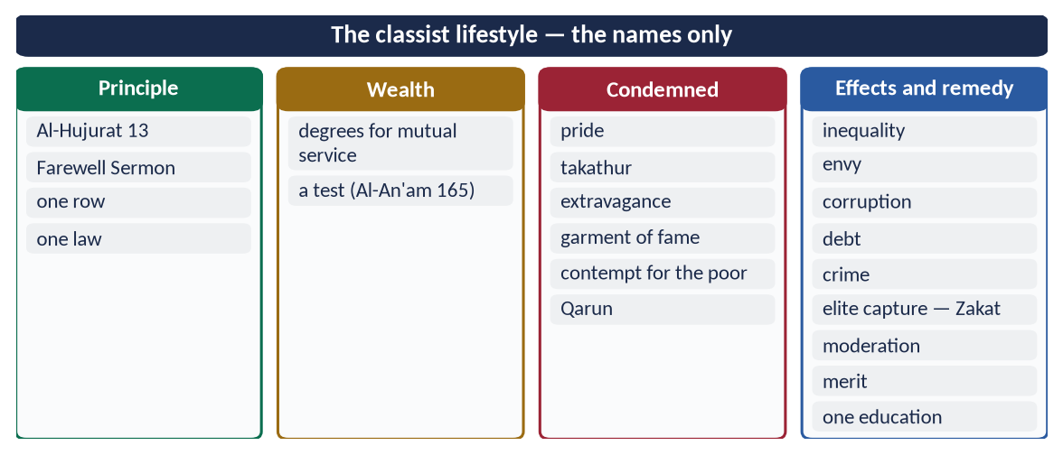
Figure 21 · At a glance — the classist lifestyle — the names only. The detail is in the sections above.

(8) Conclusion
✦ SCHOLARLY VIEW
Allama Muhammad Iqbal · Bang-e-Dra (Shikwa)
'Aik hi saf mein kharay ho gaye Mahmood-o-Ayaz' — the sultan and his slave in one row of prayer.
➜ The Islamic answer to class.

Islam permits wealth but forbids its worship and display. The classist lifestyle — pride, competition, extravagance and contempt for the poor — is condemned by the Quran and the Sunnah, and its effects — inequality, envy, corruption and unrest — are visible in our society. The cure is the Islamic balance of equality, moderation and circulation of wealth.

Why this answer scores
- A clear ruling ('status') with six proofs, distinguishing honest wealth from classism.
- A nine-point effects table with Pakistani data.
- A practical remedy and a strong conclusion.

Answer 9 · Religious Tolerance in Post-Prophetic Muslim History (CSS 2025)
THE QUESTION · CSS 2025 · Q7 · 20 marks
Discuss religious tolerance in the context of post-Prophetic Muslim history.

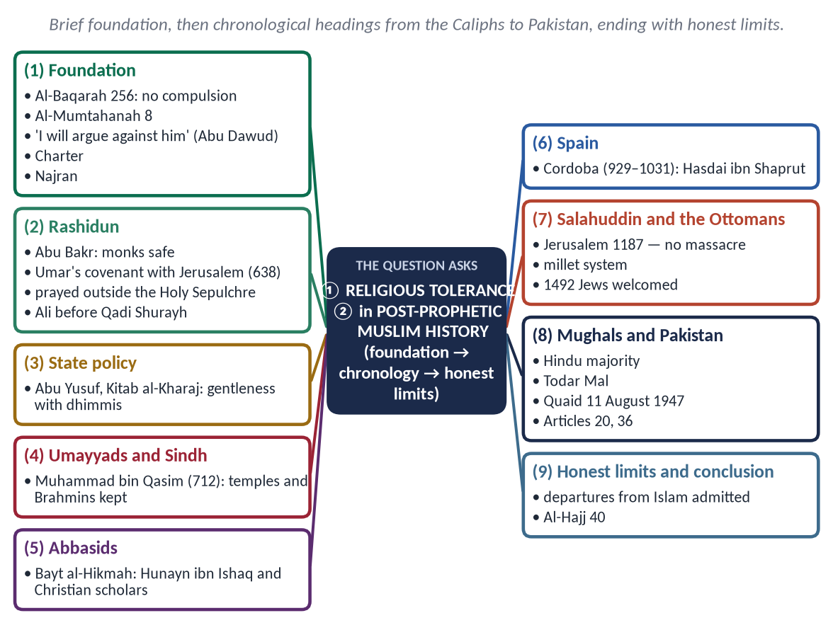
Figure 22 · The answer map: every branch is one numbered heading of the model answer below.

Decoding the question
- 'Post-Prophetic' — after 632: the Caliphs, the dynasties, up to modern times. Keep the Prophetic age to a short foundation.
- 'Discuss' — examples and an honest note on limits.
- A chronological structure is the natural choice.

The model answer

(1) Introduction
Religious tolerance — tasamuh (تَسَامُح), Urdu rawadari — means letting people of other faiths live, worship and follow their own law in peace, while holding firmly to one's own belief. The Prophet ﷺ laid its foundation; Muslim history carried it across fourteen centuries and three continents.

(2) The foundation
✦ QURAN
﴿لَآ إِكۡرَاهَ فِي ٱلدِّينِۖ قَد تَّبَيَّنَ ٱلرُّشۡدُ مِنَ ٱلۡغَيِّۚ …﴾
“There is no compulsion in religion; the right course has become clear from the wrong.” (Al-Baqarah, Quran)
➜ No compulsion in religion.

✦ QURAN
﴿لَّا يَنۡهَىٰكُمُ ٱللَّهُ عَنِ ٱلَّذِينَ لَمۡ يُقَٰتِلُوكُمۡ فِي ٱلدِّينِ وَلَمۡ يُخۡرِجُوكُم مِّن دِيَٰرِكُمۡ أَن تَبَرُّوهُمۡ وَتُقۡسِطُوٓاْ إِلَيۡهِمۡۚ إِنَّ ٱللَّهَ يُحِبُّ ٱلۡمُقۡسِطِينَ﴾
“Allah does not forbid you from those who do not fight you because of religion and do not expel you from your homes - from being righteous toward them and acting justly toward them. Indeed, Allah loves those who act justly.” (Al-Mumtahanah, Quran)
➜ Allah does not forbid you kindness and justice to those who do not fight you.

✦ HADITH
أَلَا مَنْ ظَلَمَ مُعَاهَدًا، أَوِ انْتَقَصَهُ، أَوْ كَلَّفَهُ فَوْقَ طَاقَتِهِ، أَوْ أَخَذَ مِنْهُ شَيْئًا بِغَيْرِ طِيبِ نَفْسٍ، فَأَنَا حَجِيجُهُ يَوْمَ الْقِيَامَةِ
“Whoever wrongs a non-Muslim under covenant … I will argue against him on the Day of Resurrection.” (Abu Dawud)

The Charter of Madinah ('to the Jews their religion') and the Najran treaty were the models.
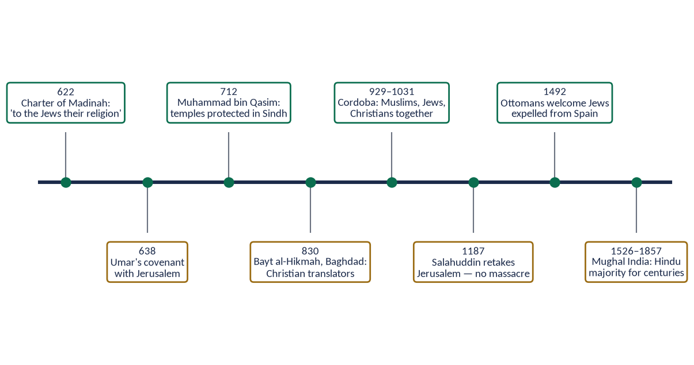
Figure 23 · Religious tolerance across Muslim history.

(3) The Rightly-Guided Caliphs (632–661)
- Abu Bakr (RA): ordered his armies not to harm monks in their cells (Muwatta).
- Umar (RA) and Jerusalem (638): his covenant with the people of Aelia guaranteed their lives, property, churches and crosses; their churches would not be occupied or demolished, and none would be compelled in religion (Al-Tabari). Invited by Patriarch Sophronius to pray in the Church of the Holy Sepulchre, he prayed outside, so that Muslims would never claim it.
- Umar (RA) gave a poor, old Jew a stipend from the treasury and exempted him from jizyah (Abu Yusuf).
- Ali (RA), as Caliph, lost his case over a shield to a non-Muslim before Qadi Shurayh.

(4) Tolerance as state policy
✦ SCHOLARLY VIEW
Imam Abu Yusuf · Kitab al-Kharaj (for Harun al-Rashid)
The chief justice instructed the Caliph to treat the non-Muslim citizens gently, to tax them within their means and to protect their lives and property, as the Prophet ﷺ and the Caliphs had done.
➜ Tolerance written into law by a Hanafi jurist.

(5) The Umayyads and Sindh (712)
Muhammad bin Qasim treated Hindus and Buddhists as protected people; temples remained in their hands and Brahmins kept their offices (Chachnama).

(6) The Abbasids — Baghdad
The Bayt al-Hikmah employed Christian, Jewish and Sabian scholars; the Nestorian Christian Hunayn ibn Ishaq led the translation of Greek science; Christian physicians attended the Caliphs.

(7) Muslim Spain — Cordoba (929–1031)
Muslims, Jews and Christians lived and worked together. Hasdai ibn Shaprut, a Jew, served as physician and minister to Caliph Abd al-Rahman III; the Jewish philosopher Maimonides later served as court physician in Egypt.

(8) Salahuddin and Jerusalem (1187)
When the Crusaders took Jerusalem in 1099, they massacred its Muslims and Jews. When Salahuddin retook it in 1187, he let the Christians leave in safety, freed many who could not pay their ransom and left the Holy Sepulchre open.

(9) The Ottomans
The millet system gave Christians and Jews their own religious leaders, courts and schools. When Spain expelled its Jews in 1492, Sultan Bayezid II welcomed them.

(10) The subcontinent and Pakistan
Muslims ruled India for centuries, yet the majority remained Hindu; Hindus such as Raja Todar Mal held the highest offices.
✦ SCHOLARLY VIEW
Quaid-e-Azam Muhammad Ali Jinnah · Address to the Constituent Assembly, 11 August 1947
You are free to go to your temples, mosques or any other places of worship in this State of Pakistan; your religion, caste or creed has nothing to do with the business of the State.
➜ The founder's pledge of equal citizenship.

Constitution: Article 20 (freedom of religion), Article 36 (protection of minorities).
Period | Example | Lesson
Rashidun | Jerusalem 638; Ali and Shurayh | Churches guaranteed; equal justice
Umayyad | Sindh 712; Cordoba | Temples protected; Jews in office
Abbasid | Bayt al-Hikmah | Christian scholars honoured
Ayyubid | Jerusalem 1187 | Mercy in victory
Ottoman | Millets; 1492 | Self-rule; refuge
Mughal / Pakistan | Hindu majority; 11 August 1947 | No forced conversion; equal citizenship

(11) Honest limits
There were also periods of discrimination and conflict in Muslim history, and today sectarian violence and attacks on minorities occur in Muslim lands. These are departures from Islam, and the Quran and Sunnah — not the worst examples — are the standard.
✦ QURAN
﴿… وَلَوۡلَا دَفۡعُ ٱللَّهِ ٱلنَّاسَ بَعۡضَهُم بِبَعۡضٖ لَّهُدِّمَتۡ صَوَٰمِعُ وَبِيَعٞ وَصَلَوَٰتٞ وَمَسَٰجِدُ يُذۡكَرُ فِيهَا ٱسۡمُ ٱللَّهِ كَثِيرٗاۗ …﴾
“Were it not that Allah checks some people by means of others, monasteries, churches, synagogues and mosques — in which Allah's name is much mentioned — would have been demolished.” (Al-Hajj, Quran)
➜ Were it not for Allah's check, monasteries, churches, synagogues and mosques would be destroyed — Islam protects all houses of worship.

(12) Conclusion
From Umar's covenant with Jerusalem to the Ottoman millets, post-Prophetic Muslim history offers one of the longest records of religious tolerance in human history — a record that made the great Muslim cities places where different faiths lived together. Pakistan's task is to live up to that record and to the Quaid's promise.

Why this answer scores
- It focuses on post-Prophetic history, as asked, with a brief foundation only.
- Chronological headings with names and dates (638, 712, 1187, 1492) show mastery.
- The honest limits section shows balance.

